Printing of Braille with 3D printers
The introduction of 3D printers in education has created a new opportunity for people to create tactile materials for students who are blind. This document seeks to inform object creators about the best way to add braille to 3D objects.
Based on testing with braille reading users and many different types of printers (Makerbot, MakerGear, TypeA, Ultimaker, and more) we found that ‘vertical braille’ is the best method of printing braille with a 3D printer (see below). Testing was conducted by the Lighthouse for the Blind and Visually Impaired in San Francisco, Texas School for the Blind and Visually Impaired, DIAGRAM Symposium on 3D Printing.

Description of Types Braille Printing
Horizontal braille occurs when the surface with braille is parallel to the build surface (printer bed). Vertical braille occurs when the surface on which the braille is printed is perpendicular to the build surface. Put another way, Horizontal Braille: printed on the floor; Vertical Braille: printed on a wall. Braille printed on an angled surface prints slightly better than horizontal braille, but should be avoided. Of course, vertical braille is not always an option, as many of the object we print are flat. Although, some flat objects can be printed vertically.
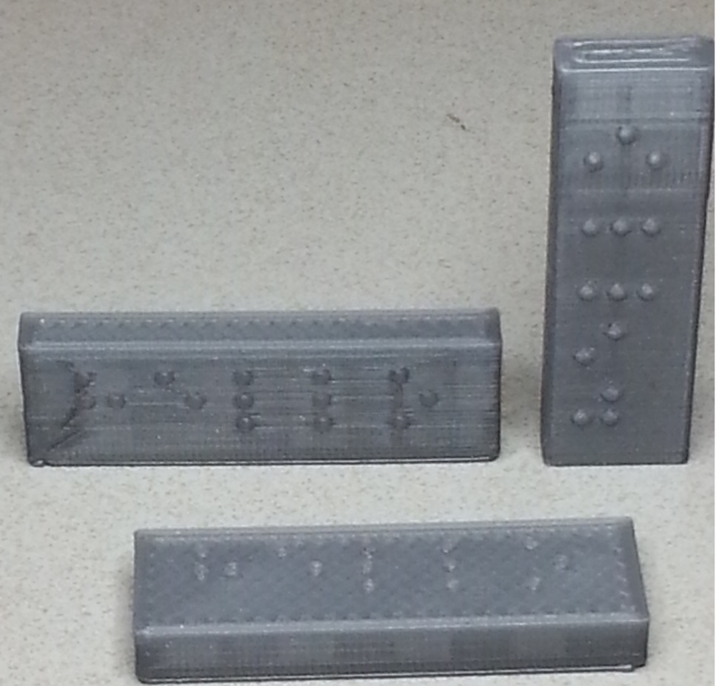
Figure 1 Test braille rectangular plates showing orientation of object during printing. All have the word “hello” in braille. Bottom plate - horizontal, Left - vertical wide, right - vertical narrow.
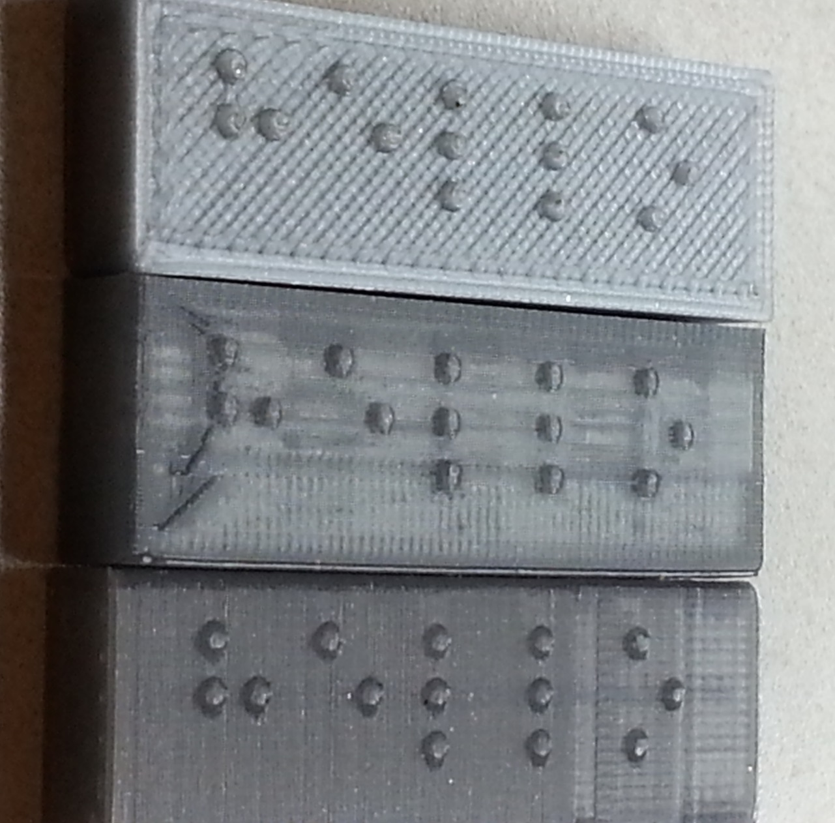
Figure 2 Close up: top - horizontal, middle - vertical wide, bottom - vertical narrow
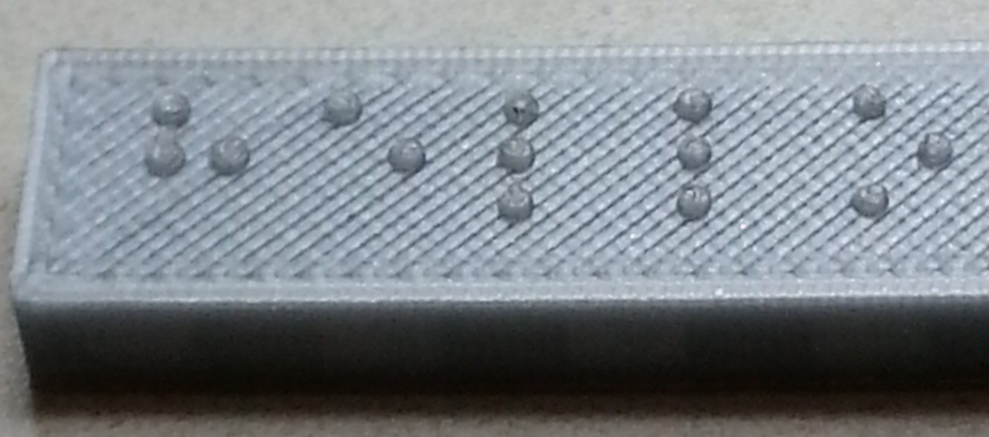
Figure 3 Horizontally Printed Braille (close-up). Notice dots are flat with edges.
Horizontal Braille prints as cylinders (layers of disks): 1.5mm diameter, 0.5mm to 0.6mm high. Think of a stack of disks creating a cylinder. The edges of the cylinders are ‘sharp.’ See Figure 3 above. That is, when reading the edges of the cylinders may snag fingers as they move across the braille. The cylinders are prone to separating at boundaries between disks. Removing a dot (cylinder) from a braille cell changes the character represented by the braille cell. See Figure 7 for braille cell configurations for alphabetic characters.

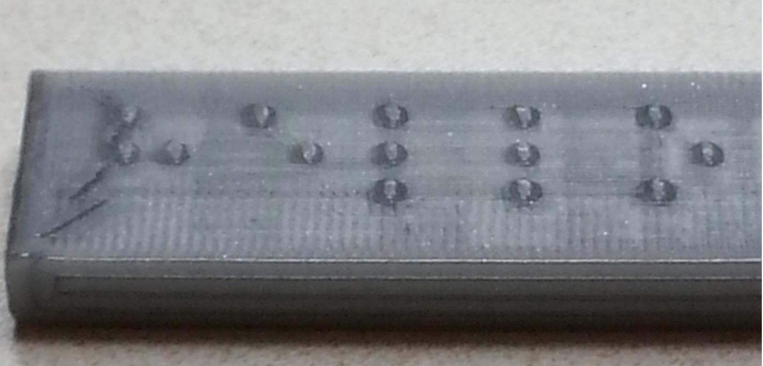
Figure 4 Vertically Printed Braille (wide) (close-up), notice the dome shape of the dots

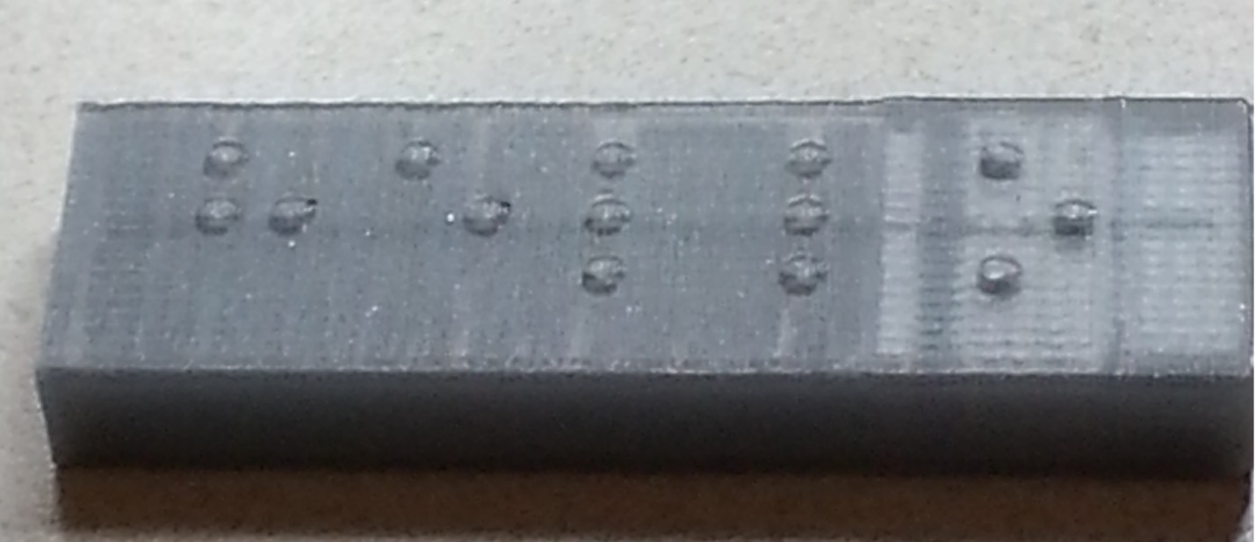
Figure 5 Vertically Printed Braille (narrow) (close-up), notice the dome shape of the dots

Vertical Braille prints best as domes: 1.5mm diameter, 0.75mm high (or a 1.5mm diameter sphere, cut in half). See Figures 4 & 5 above.

Recommendations
- Print braille vertically when possible.
- Limit the amount of 3D braille printed. It should be used for simple identification, not for large amounts of text.
- Use a key. Use 2 letter braille cells or symbols to label parts of a tactile diagram or object. Create a key explaining the 2 letter codes or symbols.
- If using more than 2 letters in a label, ask the end user (or teacher) what braille code to use for the longer labels or the key (English Braille American Edition - EBAE or Unified English Braille – UEB or Nemeth Braille Code for math and science or UEB Math).

Resources

Braille Dimensions for Signage (ADA Table 703.3.1 )
Measurement Range (see Figure 6) | Min to Max in mm
a. Distance between two dots in the same cell, vertically or horizontally. NOT diagonally. (1) | 2.3 mm to 2.5 mm
b. Dot base diameter | 1.5 mm to 1.6 mm
c. Distance horizontally between corresponding dots in adjacent cells. (1) | 6.1 mm to 7.6 mm
d. Distance vertically between corresponding dots from one cell directly below. (1) | 10 mm to 10.2 mm
e. Dot height | 0.6 mm to 0.9 mm
1. Measured center to center.
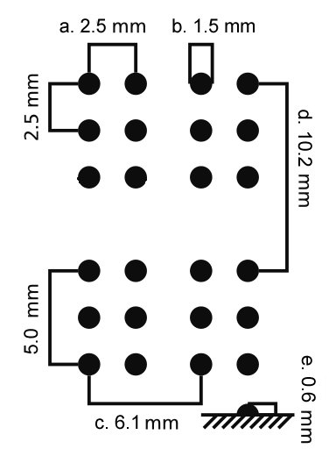 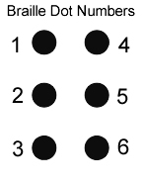
Figure 6 Braille Dimensions

Braille Alphabet
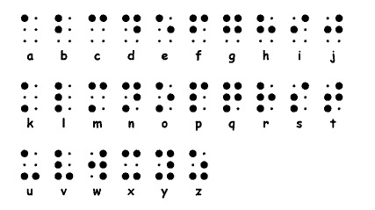
Figure 7 Braille alphabet showing arrangement of dots that make up each letter. Note: the little dots are placeholders and are not to be printed.
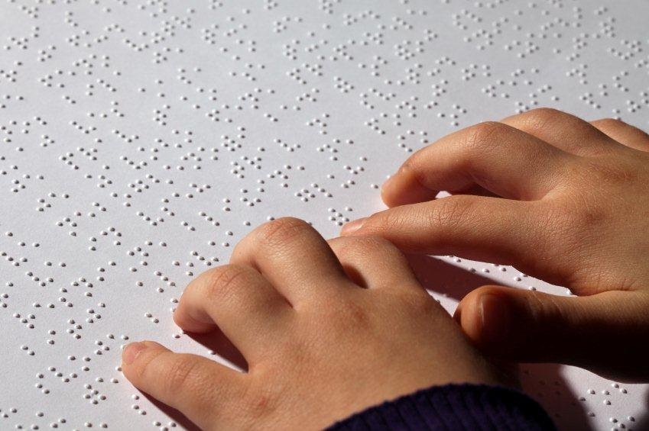
Figure 8 Braille printed on paper is a dome.
Braille: An Overview http://www.familyconnect.org/info/education/braille-4018/25
Free Braille Chart http://www.duxburysystems.com/braillechart.asp
Braille OpenSCAD Font Module http://www.thingiverse.com/thing:4758
Braille 3D utility http://v01pe.github.io/Text2Braille3d/ (in German – creates English braille)
Braille 3D text creator https://github.com/KitWallace/openscad/blob/master/braille.scad

