DIAGRAM Center Working Paper – April 2016

Potential Use of Image-Description Metadata for Accessibility

Addendum: Standards and Recommendations,

Metadata, Screen Readers, Tools, Guidelines

Introduction
The tools described in the initial Potential Use of Image-Description Metadata for Accessibility report (2011) embed metadata as part of the image so that, in theory, the metadata will always travel with the image no matter how or where the image is processed. However, today as in 2011 the typical publication workflow utilizes many different tools from different vendors, and it is not always possible to maintain embedded metadata all the way through the production chain. Practical solutions that are in use today work around these limitations by associating a long description with its image via a URL, or linking an image to a description that is stored locally in a separate directory as part of a larger, downloadable book package. In some cases, authors may simply reference a description that is contained in visible text elsewhere on the same page. All of the approaches are viable, yet none provide a singular, reliable solution that is appropriate in all contexts.

This document describes changes and improvements made since the 2013 addendum to the original 2011 paper about image descriptions and metadata. Basic procedures and methods for adding long descriptions to images remain essentially the same: images can be described directly within the text of a book, or they can be coded in a manner that allows them to be hidden yet still discovered and voiced by assistive technology or even by browser plug-ins or add-ons. An image can be separately produced as a tactile graphic using a variety of techniques that place a raised image on paper or a tactile display. Three-dimensional models can be made for the student to touch. However, there continues to be significant progress in some areas that gives authors more options for providing image descriptions in various formats. Additionally, important tools for adding image descriptions to digital talking books and e-books-- Tobi and Poet-- continue to receive upgrades that improve how they author and process long image descriptions.

Standards and recommendations
Successful implementation and proliferation of any of the metadata solutions described in the original report have always depended in large part on the outcome of a number of ongoing standards and best-practices discussions. When it comes to image descriptions, the most influential group at work today continues to be the HTML5 Working Group at the World Wide Web Consortium (W3C). In approximately 2007, the working group removed the longdesc attribute from the HTML5 recommendation, immediately placing a long-standing method for conveying long image descriptions to users in jeopardy, and setting off a years-long debate about the purpose and worthiness of longdesc itself. As a result, other working groups developed their own HTML-based standards because they no longer had a de facto method of specifying how long descriptions should be delivered to users.

In 2015, a major breakthrough occurred: the W3C Web Accessibility Initiative's (WAI) Accessibility Task Force and Protocols and Formats Working Group, in conjunction with many others in the accessibility industry, including members of the DIAGRAM project, won a reversal of sorts by receiving the W3C's approval to publish the HTML5 Image Description Extension (longdesc), an addendum to the full HTML specification that clearly describes the purpose and behavior of the original longdesc attribute. Part of the original conflict over longdesc was that it was never published with sufficient detail about how it should be implemented by authors and user agents. It was this original lack of detail that may have led to the attribute's misuse and lack of implementation, both of which contributed to its removal from the HTML5 recommendation.

The longdesc attribute extension specification is now an official W3C recommendation (although not without objections: read the Formal Objection to Advancing the HTML Image Description Document). It is very important to note, however, that this iteration of the longdesc attribute does not focus on improvements to the attribute. Instead, it specifies how it operates now (i.e., linking a machine-discoverable long description to an image via a URL), thereby providing a baseline summary that was never written into the original specification of the attribute. As such, this extension specification will provide a solid base on which subsequent improvements can be constructed.

Now that the HTML5 Image Description Extension has been published, focus has shifted to creating new long-description delivery methods, or improving existing ones. Currently, one of the longdesc attribute's major limitations is that it can only be applied to the img element. However, rather than redefine the longdesc attribute to accommodate new features, the conversation has turned to replacing or, more likely, recommending alternative methods for conveying image descriptions. Four years ago, a new attribute was proposed for inclusion in the ARIA recommendation which would provide a mechanism for linking long descriptions to any element, not just images. This attribute, aria-describedat, was being considered for inclusion in ARIA 1.1 but it has been removed from the draft recommendation due to the lack of support from user-agent vendors. Instead, a new property, aria-details, has been proposed for inclusion in ARIA 1.1. Authors can also take advantage of other new elements in HTML 5 and HTML 5.1 (currently in draft form), such as the figure and figcaption elements. Other elements, such as details and summary, will give authors a way to provide long descriptions in a manner that is not restricted to just users of assistive technology. For example, the details element provides a visible disclosure device or widget, such as a twisty or expand/collapse control, which can be used to reveal or hide supplemental information about an object. In the case of an image, selecting the control could reveal a long description (presented via the summary element) that could be read aloud by a screen reader, or simply read by anyone who wanted to reveal it. Here is a brief example of the markup:

<details>
<summary>
<img src="myPicture.jpg" />
</summary>
<p>Here is a long description of myPicture.jpg. You can include any markup here (e.g., tables, lists) that you want!</p>
</details>

You can also view a working sample of a long description delivered using the details and summary elements, but note that it may not yet be presented properly in all browsers: some, such as Safari and Chrome, provide a native expand/collapse control, whereas Firefox and IE do not yet have this capability. Assistive-technology support is also inconsistent at this point because details and summary are not yet fully specified. For the time being, authors who want to explore this method may need to provide scripted controls that reveal and hide the descriptions. Even so, this approach may become one among several that can be used in the near future to convey long image descriptions to users. A work-in-progress chart from the W3C summarizes existing support for conveying and reading long image descriptions. Also check Can I Use? for up-to-date browser support of these and other elements.

Diagrammar
In 2014, the DIAGRAM Center released Diagrammar, formerly known as the Content Model, as a data model for image-description metadata. Diagrammar can be thought of as a container that presents alternatives for images, be they summaries, long descriptions, simplified descriptions, pointers to tactile models or braille, etc. The container is composed of markup that points to, or even contains, the image alternatives, and user agents and assistive technologies give users the ability to select from among the supported alternatives. Example Diagrammar markup shows how the container can be structured. Tobi, a tool for converting DAISY or EPUB documents into digital talking books (DTBs), now includes an editor that uses Diagrammar for adding descriptions or other assets to documents..

Metadata about accessibility
Accessibility metadata for describing resources on the Web has been added to Schema.org so that search engines can index information about the accessibility of a resource (e.g., a video, e-book or other digital publication) and thus make that resource discoverable by its accessibility attributes. Schema.org is a community of Web authors and search-tool vendors, including Google, Bing, Yahoo! and Yandex. The Accessibility Metadata Project documents the specification and provides supporting resources for authors who need to describe or “tag” the accessibility attributes of both content and alternatives on the Web. Doing so opens up new and important possibilities for search and delivery, as well as discovery of accessible adaptations.

Four accessibility properties are now part of Schema.org:
- accessibilityAPI
- accessibilityControl
- accessibilityHazard
- accessibilityFeature

Some of the tags that authors might want to add to images are listed below. These are terms that can be included in the accessibilityFeature property. Note that a single image can contain multiple tags, and that there is no limit to the number of tags that authors may add to each image (or other resource).

- alternativeText: Alternative text is provided for visual content (e.g., via the HTML alt attribute).
- braille: The content is in braille format, or alternatives are available in braille.
- highContrastDisplay: Content meets the visual contrast threshold set out in WCAG Success Criteria 1.4.6.
- longDescription: Descriptions are provided for image-based visual content and/or complex structures such as tables, mathematics, diagrams and charts.
- tactileGraphic: Tactile graphics are provided.

Accessibility metadata can be used to describe the types of content provided in a Diagrammar file to expose the alternatives provided to a wider search.

It is now up to the search companies that participate in Schema.org to add this metadata to their search algorithms. For now, a Google Custom Search Engine can be used to search for resources with accessibility metadata. Results show that there is accessibility metadata in use in collections from Bookshare, Hathi Trust, OpenLibra, Bibliothèque Numérique Francophone Accessible, Kahn Academy, Yahoo! News, YouDescribe, and many smaller Web sites using video players or plug-ins that implement accessibility metadata. The automated tools at Schema.org estimate that the accessibilityFeature term is used on between 100 and 1000 domains at the time of this report.

Here is an example of metadata code from the Bookshare collection:

From the page for Holt Science & Technology, Physical Science
<meta itemprop="accessibilityHazard" content="noFlashingHazard"/>
<meta itemprop="accessibilityHazard" content="noMotionSimulationHazard"/>
<meta itemprop="accessibilityHazard" content="noSoundHazard"/>
<meta itemprop="accessibilityAPI" content="ARIA"/>
<meta itemprop="accessibilityFeature" content="alternativeText"/>
<meta itemprop="accessibilityControl" content="fullKeyboardControl"/>

Google currently offers a search tool for finding captioned videos, but it appears to rely on internal YouTube metadata rather than Schema.org metadata at this point. Once accessibility metadata has been more fully implemented, and Web authors have marked up their media collections with the appropriate metadata, users will be able to use search engines to search for resources that have been marked up with accessibility metadata as detailed in the full specification. Thus, when conducting a search for images related to (for example) pollination, a user could restrict that search only to images that have long descriptions, or to those that have been supplied with tactile alternatives. This outcome relies on the search engines implementing the metadata, and on content repositories marking up their content. The Accessibility Metadata Project team is actively seeking implementers of all kinds, including tools for tagging as well as large collections that might tag their materials.

Additional work is in progress to improve this accessibility metadata to better handle multimedia e-books as part of the work on the next version of the ePub standard. A proposal for three additional metadata elements has been submitted, with use cases detailed on the ePub Accessibility Wiki. That work will be announced on the Accessibility Metadata Project Web page when it is ready for use.

Screen readers and browsers
As reported in the 2013 version of this paper, JAWS for Windows, NVDA and ChromeVox now provide support for longdesc. VoiceOver, the screen reader built into all OS X computers and iOS devices (as well as the Apple Watch and Apple TV), remains the only major screen reader that does not support the longdesc attribute.

Some browsers are now making it possible for non-AT users to access long image descriptions. Mozilla has added a new feature to Firefox that gives users access to long images conveyed with the longdesc attribute. When a page is displayed that contains an image that includes the longdesc attribute, users can right-click on the image and see a "View Description" option. Selecting this option displays the long description visually. Below is an image of the context menu.

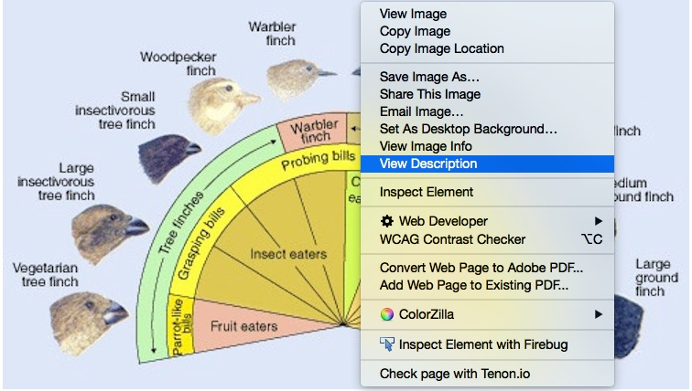

A similar feature is available in Chrome via the Long Descriptions in Context Menu add-on, as shown below.

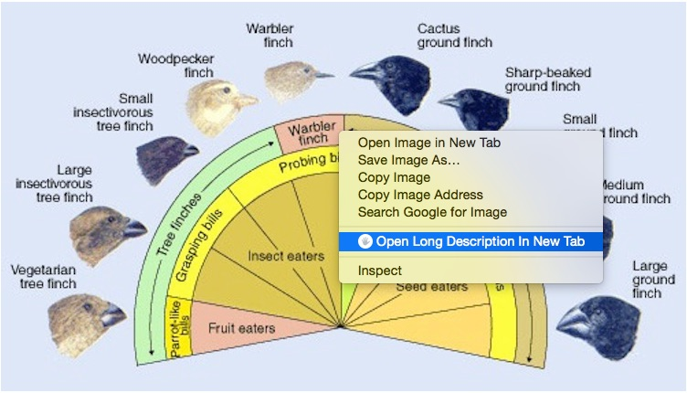

Both browsers require the use of a mouse to display the context menu, so currently neither are available to keyboard users. Providing keyboard access to long descriptions in Firefox has been topic of discussion at Mozilla, however, so it is possible that keyboard support will be included in future versions of the browser.

Tools
The 2012 and 2013 reports summarized the features of two useful tools, Poet and Tobi, for adding descriptions to digital publications. Both of these applications have been recently updated or are in the process of being updated; summaries of their new features and capabilities are provided below.

- Tobi
Tobi is a free, open-source multimedia-production application (Windows only) from the DAISY Consortium that creates DAISY-formatted digital talking books (DTBs) and EPUB 3 documents. It allows authors to synchronize text with human narration as well as text-to-speech (TTS) narration, resulting in what are commonly known as talking books.

Tobi has undergone steady improvements since its initial launch in 2010. In late 2015, Tobi version 2.6.0.0 was released. New features include mapping between document structure types and specific voice names (e.g., for associating a single voice type with image descriptions, or with a single heading style); improved support for adding metadata; simplified and more reliable method of converting DTBs to EPUB 3 documents, and structural-editing capabilities. Tobi also integrates an editor for the Diagrammar to make it easier for authors to add long descriptions or other image alternatives to Tobi projects. As with previous versions, Tobi continues to create talking books using EPUB3 Media Overlays, a method of synchronizing audio narration with EPUB3 documents. Note that EPUB3 Media Overlays is based on SMIL (Synchronized Multimedia Integration Language), a W3C recommendation for representing synchronized multimedia information in XML. Download a sample EPUB book with media overlays (first two chapters), take a look at a sample source-code file showing media overlays, or download a sample talking book created with Tobi.

- Poet
The Poet image-description tool was developed by the DIAGRAM Center as an open-source resource to make it easier to create image descriptions for DAISY books, and to allow crowd sourcing of image descriptions to reduce cost. The tool is used to add image descriptions to existing books and may be accessed for free from Benetech. Alternatively, the code may be downloaded, installed and managed by the user.

Development is underway on a number of improvements to Poet, among them new training materials that will help authors who are writing descriptions for math- and science-related images. The new materials will include interactive exercises and best practices, and will include the image-description guidelines from the DIAGRAM Center. Poet will also incorporate template-based forms created by Touch Graphics and MathTrax to facilitate description writing for specific image types.

Guidelines
Software tools and applications are only one part (albeit an important part) of the image-description process. Of equal importance are guidelines or training materials. The description that authors write for any image, especially those that illustrate scientific or mathematical concepts, will vary depending on context and usage, and the amount of material to include in a description will be different from one usage to the next. Fortunately, there are a number of resources available to help authors learn how to write descriptions that are appropriate for all kinds of images, be they simple or complex. Here is a list that includes not only guidelines but also tutorials and practice materials.
- DIAGRAM Image Description Guidelines
Complete information about describing images of all types. You can also download the guidelines as a Word document.
- Decision Tree
A tool to help you determine whether images should be presented using long descriptions or using tactile representations.
- Accessible Image Sample Book
A free online resource that shows you what some of the many options are for creating accessible versions of digital images, such as maps, bar charts, mathematical expressions, etc.
- Image Description Resources from NCAM
Guidelines for creating image descriptions for specific purposes, such as describing STEM images or describing images for assessments, as well as links to Webinars hosted by NCAM and DIAGRAM staff about all aspects of image descriptions.
- DIAGRAM Webinars
Webinars that cover image descriptions as well as related topics, such as accessible math; tactile graphics; interactive widgets, 3D printing and more.
- DIAGRAM-related resources
A complete list of resources associated with the work underway as part of the DIAGRAM project.

Adobe's Creative Cloud applications
The original 2011 image-metadata paper was based in large part on the use of tools found in Adobe's Creative Suite 5 (CS5). After the paper was published Adobe released CS5.5; relevant applications in that suite (such as Illustrator, InDesign, Bridge and Photoshop) were examined and tested, and the results of those tests were published in the 2012 addendum. In mid-2012, Adobe released CS6 as well as Creative Cloud, which is a subscription-based collection of applications that has now supplanted downloadable versions of Creative Suite.

As with previous versions of Creative Suite applications, image-description metadata can be added to JPG, PNG and other image formats in Bridge. This metadata is then made available in Illustrator and InDesign, and also travels with the image when exported to other formats, such as PDF, HTML and EPUB formats. For example, if the image is integrated into a PDF, the image description is placed into the Alternative Text field of the image's Object Properties. Or, if exported to HTML, the image description is simply placed into the alt attribute (i.e., <img src="myimage.jpg" alt="image description" />). However, image-description metadata that is added to a PNG using Photoshop remains unavailable when the image is opened in Bridge, Illustrator or InDesign. However, metadata can instead be added to a PNG using Bridge, and that information will become available when the image is opened in other Creative Cloud applications, and will be available in exported documents. (Image metadata can also be added to PNGs using other applications, such as GIMP.) This inconsistency does not prohibit authors from attaching descriptive metadata to images that will travel with those images as they are passed through the publication processes, but authors should simply keep this point in mind when adding metadata to images using Creative Cloud applications. At this time, however, no assistive technology can directly access the image-description metadata stored within an image.

Summary
In the past two years, substantial gains have been made in standards and recommendations regarding the inclusion of long descriptions with images. The resolution of conflicts, both technical and philosophical, around the longdesc attribute in HTML5 finally allows authors to provide descriptions in a basic, standards-approved method that can be reliably supported from one end of the digital-publication chain to the other, regardless of if the materials are created in HTML, EPUB or DTB formats. Important assistive-technology and browser vendors, such as Freedom Scientific, NVDA, Google and Mozilla, realizing the value that longdesc brings to users, have added or maintained their support for this description-delivery method in their products, giving users more options than ever before when it comes to accessing long image descriptions.

Still, authors who wish to actually embed descriptive metadata in images, and who want that metadata to be available for manipulation throughout the production process, will find that no easy and permanent solution has yet been reached. Authors can embed descriptions in images but, depending on the image type, conventional workflows may need to be altered in order to accommodate extra steps. Additionally, the problem of access by users remains: no assistive technology currently available can locate and read descriptive metadata embedded within images. Ongoing discussions with standards groups and tool developers will continue efforts to extend support for long descriptions within image formats and authoring tools.

Additional References
- EXIF specifications
- IPTC Photo Metadata Specification
- Dublin Core Metadata Element Set, Version 1.1
- Metadata Working Group Specifications
- Adobe XMP Development Center
- Accessibility Features of SVG
- SVG 1.1 title and desc attributes
- Accessible Infographics Community Group
- Providing Alt Text for Images: An Overview

As with any Web initiative, different organizations may take different approaches to the use of accessibility metadata, some of which may be unorthodox.

