3D-Printed Teaching Aids
for Students with Visual Impairments
Final Report
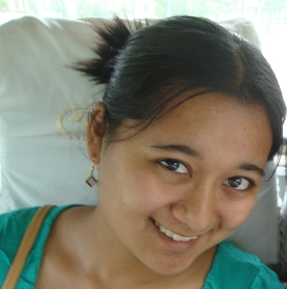
Ayna Agarwal Shaheen Jeeawoody Maya Yamane

Team Walrus!
ENGR 110
Perspectives in Assistive Technology
March 17, 2014
Corporate Partner:

Abstract
To address the low representation of students with visual impairments in STEM (Science, Technology, Engineering, and Mathematics) fields, the issue of making scientific images and concepts accessible is receiving increasing attention. Companies such as Benetech are devoted to making diagrams accessible to students with visual impairments using 3D printed educational aids. This project seeks to support Benetech’s work in this field through (1) conducting literature and interview-based research to assess the need for 3D-printed teaching aids and existing solutions in this arena, and (2) designing and printing novel 3D objects that can serve as learning aids for high school students with visual impairments studying STEM. Interviews with teachers, students, academics, and other professionals revealed a need for 3D models that depict math graphs, algebraic equations, chemical reactions, anatomy, and biological processes, as well as limitations of tactile graphics. Based on insights from our research and further brainstorming, we designed and printed a set of original 3D objects modeling the central dogma of biology: transcription of DNA to RNA, and translation of RNA to a protein. Such a learning tool will allow students with visual impairments to better understand this fundamental biological process, and this first-hand experience with designing and printing 3D educational aids also shed insight on the feasibility of replicating this process in future classrooms.
Introduction
The National Science Foundation attests that “a well-prepared, innovative science, technology, engineering and mathematics (STEM) workforce is crucial to the Nation’s health and economy” (National Science Foundation). Such a workforce needs a diversity of thought and ability. Accordingly, the Research in Disabilities Education (RDE) program of the NSF is making an effort to broaden the participation of students with disabilities in STEM fields. Students with disabilities are underrepresented in STEM fields, with only 9-10% of these students pursuing STEM degrees at the undergraduate level (Figure 1a), and 20% of those in the National Workforce with a disability working in the STEM profession (Figure 1b, Moon, Morton, 11-12).
A.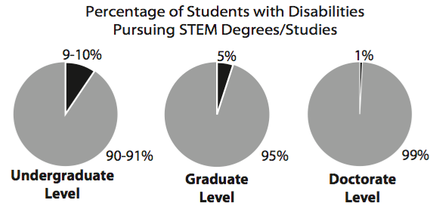 B. 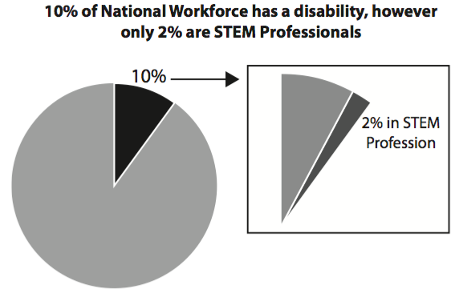
Figure 1: Statistics on people with disabilities who are (A) studying STEM,
and (B) STEM professionals (Moon, Morton).
This low representation of people with a disability in STEM fields can be traced back to K-12 science and mathematics classes. Students are often not adequately accommodated and are faced with social, cultural, financial, and political barriers to educational accessibility.
Students with visual impairments, in particular, may find STEM learning increasingly difficult because of the large number of concepts in these fields that require visual representation through diagrams, graphs, charts, or other technical notation (Jones, Broadwell 283-285). Complex processes such as organic chemistry reactions or the Krebs cycle are primarily taught through visual diagrams in textbooks and/or electronic formats. Further, subjects such as math are often taught using the “chalk and talk” method, which may be difficult for blind or partially sighted students to follow (Cryer 13). To facilitate these students’ understanding of STEM concepts, a variety of solutions have and are being developed.
The American Printing House for the Blind (APH) is “the world’s largest nonprofit organization creating educational, workplace, and independent living products and services for people who are visually impaired” (aph.org). APH has a variety of educational materials for sale, including accessible textbooks, tactile graphics, and software. Tactile graphics are raised 2D images that a person with a visual impairment can run their fingers along, allowing him/her to feel the different textures, height, width, and spatial orientation of the image (Figure 2).
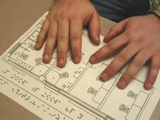
Figure 2. Example of a tactile graphic (www.pathstoliteracy.org/tactile-graphics).
Each American public school district is allotted a specified amount of federal quota funds per student with a visual impairment to purchase APH materials. Quota spending is regulated by the Ex Officio Trustee for every district or educational department. However, only APH-specific products are eligible for purchase with quota funds, and products often exceed the allocation to each student (Bobnar). Aside from APH, a variety of lesson plans, online toolkits, and research initiatives are aimed at enhancing STEM accessibility for students with disabilities (Appendix 1).
While many tools are being developed to facilitate STEM education, the use of 3D printing in this field so far is limited (Weaver, Bouvry). Benetech, the nonprofit company who proposed this project (Figure 3), hopes to build a centralized repository containing files for 3D printing teaching aids. Benetech currently approaches literacy accessibility through operating Bookshare, the world’s largest accessible library (benetech.org). While text can be translated into accessible formats via Bookshare, diagrams, which are often present in STEM literature, cannot be depicted in the same manner. Thus, Benetech launched The DIAGRAM Center--a research and development initiative to ensure accessibility of images for people with visual impairments (diagramcenter.org). DIAGRAM explores image accessibility through means such as tactile graphics, haptic feedback, interactive graphics, and 3D printing.
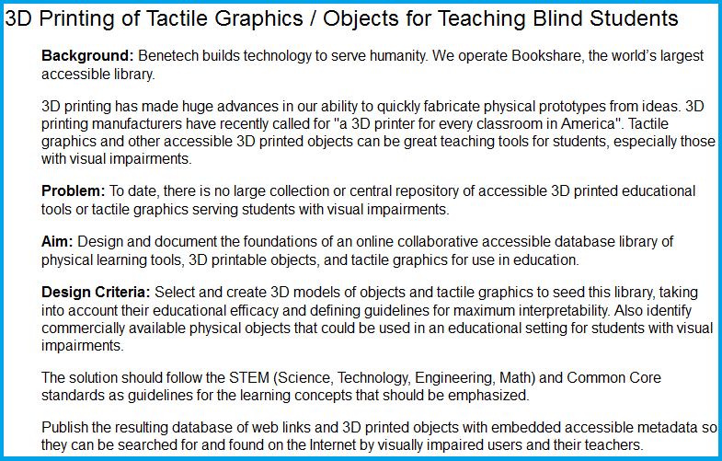
Figure 3. Project prompt as given by Benetech for Team Walrus!
3D printing can be a valuable tool to create teaching aids for students with visual impairments for a variety of reasons. Much like an inkjet printer, 3D printers use information from a digital file to deposit layers of material until the desired object is completed (“A Visual History of 3D Printing”). This fabrication process allows for an array of 3D-printable objects, extending from toys and medical implants, to iPhone cases and food. Compared to a time-scale of weeks, which is required for materials to be shipped from places like APH to classrooms, 3D printing an object is on the scale of a few hours. Creating a repository of 3D teaching aids, as Benetech hopes to do, will allow teachers to share 3D files, eliminating the need for each teacher to create original graphics for his or her students. With these limitless possibilities, it is thought that 3D printing will be able to transform the future of education, allowing students to design and print their own models for microscopic and/or intangible processes.
Thus, this project seeks to utilize 3D printing to enhance STEM learning for students with visual impairments through two main objectives:
- To further understand this issue by assessing the need for 3D-printed teaching aids for students with visual impairments, accomplished through interview and literature-based research.
- To design and print appropriate and unique 3D objects based on the aforementioned research that can serve as teaching aids specifically geared toward high school students studying STEM subjects who have a visual impairment.

Design Criteria
Much of our background research consisted of inquiring about current stakeholder sympathies, existing educational aids for students with a visual impairment, access to those solutions, and design specifications for 3D printed teaching aids. The perspectives of teachers, students with visual impairments, researchers studying 3D printing as an educational tool for aiding students with visual impairments, and Stanford’s Office of Accessible Education were considered.
As mentioned above, Benetech requested that any 3D printed teaching aids we produced should be suitable for middle or high school students with a visual impairment studying a STEM subject. However, the specific concept and how we wanted to approach the design process was left to our discretion. Benetech also provided us with resources to jump-start our search for interviewees in the community. The takeaways of our interviews can be categorized as follows:
1) STEM subjects that can benefit from new teaching aids
The students we interviewed both expressed difficulty in understanding graphs, due to the fact that they require a lot of manipulation as coordinates do not stay in a fixed position. In higher level math classes, which Stanford’s Office of Accessible Education (OAE) creates tactile graphics for, graphs often contain x, y, and z axes, portraying a 3D object. Feeling an example of a tactile graphic depicting a 3D shape allowed us to empathize with the difficulty in interpreting these graphs. Other subjects that our student interviewees expressed difficulty with include biology (i.e. DNA, cells, dissections, organs) and chemistry (i.e. chemical equations, molecules). One student mentioned that anything with complex structures or layers is difficult to portray using a tactile graphic and could benefit from a 3D object. One student explained that chemical equations include many complex symbols that are cumbersome to use with a screen reader, and another student shared that having models of cells, DNA, and organs were helpful, even if they were makeshift, homemade models. The OAE also mentioned anatomy as a subject that would benefit from 3D-printed objects, an insight from working with a blind student taking SURG 101: Regional Study of Human Structure.
2) Existing educational aids - accessibility, cost, and durability
The perspective of the two blind students we interviewed was especially helpful in understanding the assistive technology they currently use. Both used a screen reader, and one mentioned having used tactile graphics in high school. Often, “primitive” methods of learning STEM subjects was used, such as creating and memorizing an incremental log chart, or having someone make a model of a cell out of materials found around the house. They also pointed us in the direction of exploring resources such as the American Printing House for the Blind, the National Braille Press, DAISY formatted books, and software such as MathTrax and MathML.
The cost of educational aids, both in time and money, is also an issue. One student, who is from India, explained that materials such as tactile graph paper are not easily accessible in India. In the United States, accessible materials should in theory be at least partially subsidized by the government, however, one teacher said that her “school does not have money for math and science to be creative.” The OAE also explained the high cost of producing tactile graphics because of the expensive machinery they use and the time required to design each graphic. It takes approximately one day to print 5-10 pages in tactile graphic format, and two weeks to translate one chapter into Braille.
Another interviewee, who was both an instructor for students with visual impairments and an academic and research consultant in the field, emphasized the time intensiveness to create tactile graphics. As a teacher, she took 2-3 hours each night building for the next day’s lesson plan. These graphics were made for specific lessons plans and were not easily translatable for standardized tests. Further, the graphics fell apart easily and usually could not be recycled.
3) Design specifications to consider for 3D-printed objects
Texture, spacing, and scale
Stanford’s Office of Accessible Education, upon showing us examples of the tactile graphics they produce and the machinery required to make them, also pointed out design criteria to keep in mind when designing aids for students with visual impairments. Because people with visual impairments are often highly sensitized to touch, it is important to take note of specifications such as line thickness, spacing, and textures. As an art teacher from Jordan Middle School pointed out, whereas a sighted individual often uses color to differentiate objects, emotions, and ideas, color needs to be expressed through different means such as texture for those lacking the sense of sight. When making tactile graphics, lines need to be spaced a minimum width apart to allow for clear distinction. The scale of the objects being represented was another very important design specification mentioned in our interviews. For example, even if presented with a detailed model of an elephant, a blind person still will not be able to comprehend the size of the animal by feeling this miniaturized figurine. Thus, in dealing with subjects such as anatomy, it is crucial that organs, bones, etc. be true to life size so that the student can comprehend the scale of these objects.
Including Braille or audio enhancements
Many existing learning aids for students with visual impairments, 3D printed or not, include a braille and/or audio component to explain what the learning aid is trying to convey. For example, the Touch Graphics STEM Binder introduced to us by Benetech contains tactile graphics with a “talking” pen that verbalizes an explanation of the diagram. Additionally, one of the academics who designs and prints 3D teaching aids also includes braille directly on the object. This same interviewee provided us with detailed specifications to write braille on objects in OpenSCAD. One student mentioned that not every blind person knows how to read braille and that listening is much faster than reading braille, which could be limitations in a design with braille.
Re-usability
As mentioned in section 2, a drawback to tactile graphics is their fragility, so new aids need to be designed for each lesson and each student. Thus, another important design criterion is that our object be durable enough to withstand repeated use. Because the input for a 3D printer is an electronic STL file, in theory, the learning aid should be able to be printed and re-printed multiple times without the need for complete re-design.
Suitability for 3D printing
As one of our lecturers Gary Berke, MS, CP, FAAOP mentioned, “just because you have a 3D printer, it doesn’t mean that everything needs to be 3D printed.” This piece of advice is key for our technology-driven project. Although the main design criteria suggested by Benetech was to use a 3D printer, we needed to assure than any object we designed was better suited for 3D printing than another format. One of our interviewees in academia also echoed this piece of advice. She stated that “3D printing could never replace tactile graphics,” because there are not enough texture differences. Some concepts can be more precisely and easily portrayed using tactile graphics, such as maps, whereas things that you normally view from 360º and without as much minute detail may be more suitable for 3D printing.
Even if non 3D-printed models currently exist in the consumer marketplace for a given object, creating an STL file of it could still be valuable for Benetech’s repository because they are customizable and 3D printers will ideally be more accessible and usable in classrooms than ordering kits in the future. One of our interviewees who had firsthand experience designing 3D objects warned us of the time required to design in programs like SketchUp and SolidWorks, so the complexity of the object was also a practical yet important design criterion.

Methods
Brainstorming Process
We incorporated the design criteria presented above as we brainstormed what type of object(s) to design and print. Since graphs were mentioned often as concepts that students with visual impairments seem to have difficulty grasping, we started by exploring this area. First, we brainstormed methods of showcasing standard 2D graphs (Figure 4a) that include x and y axes and points and areas of intersection. We originally conceived of a grid-like pattern upon which students and teachers can overlay simple line graphs and create junctions to showcase intersections. Printing new lines and curves to fit onto the grid would be quick and require minimal material. Upon reflection, however, we concluded that because of their need to be quickly changed and manipulated, 2D graphs would be better portrayed using embossing paper.
A. 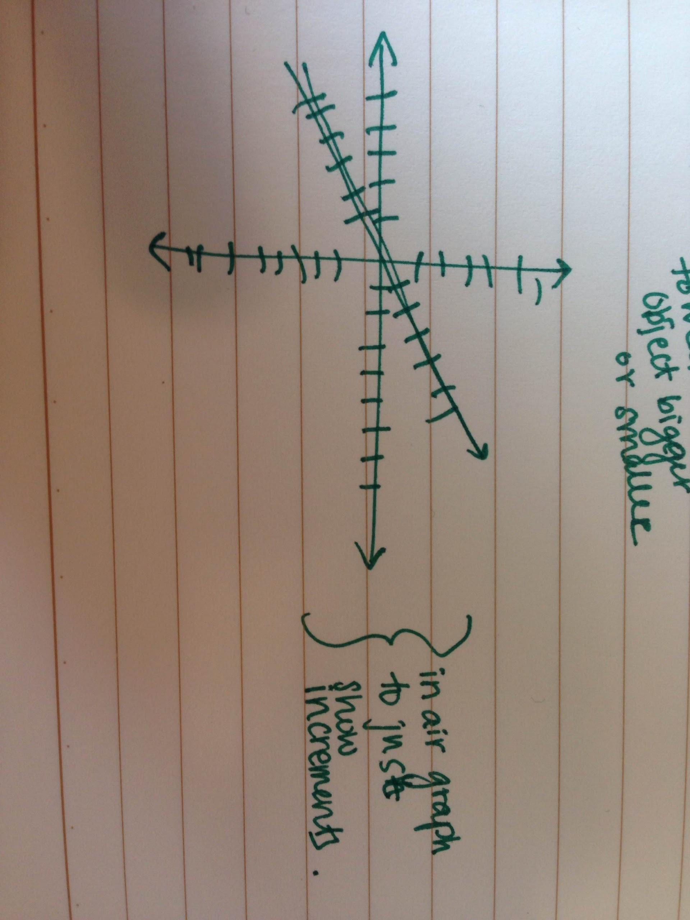 B. 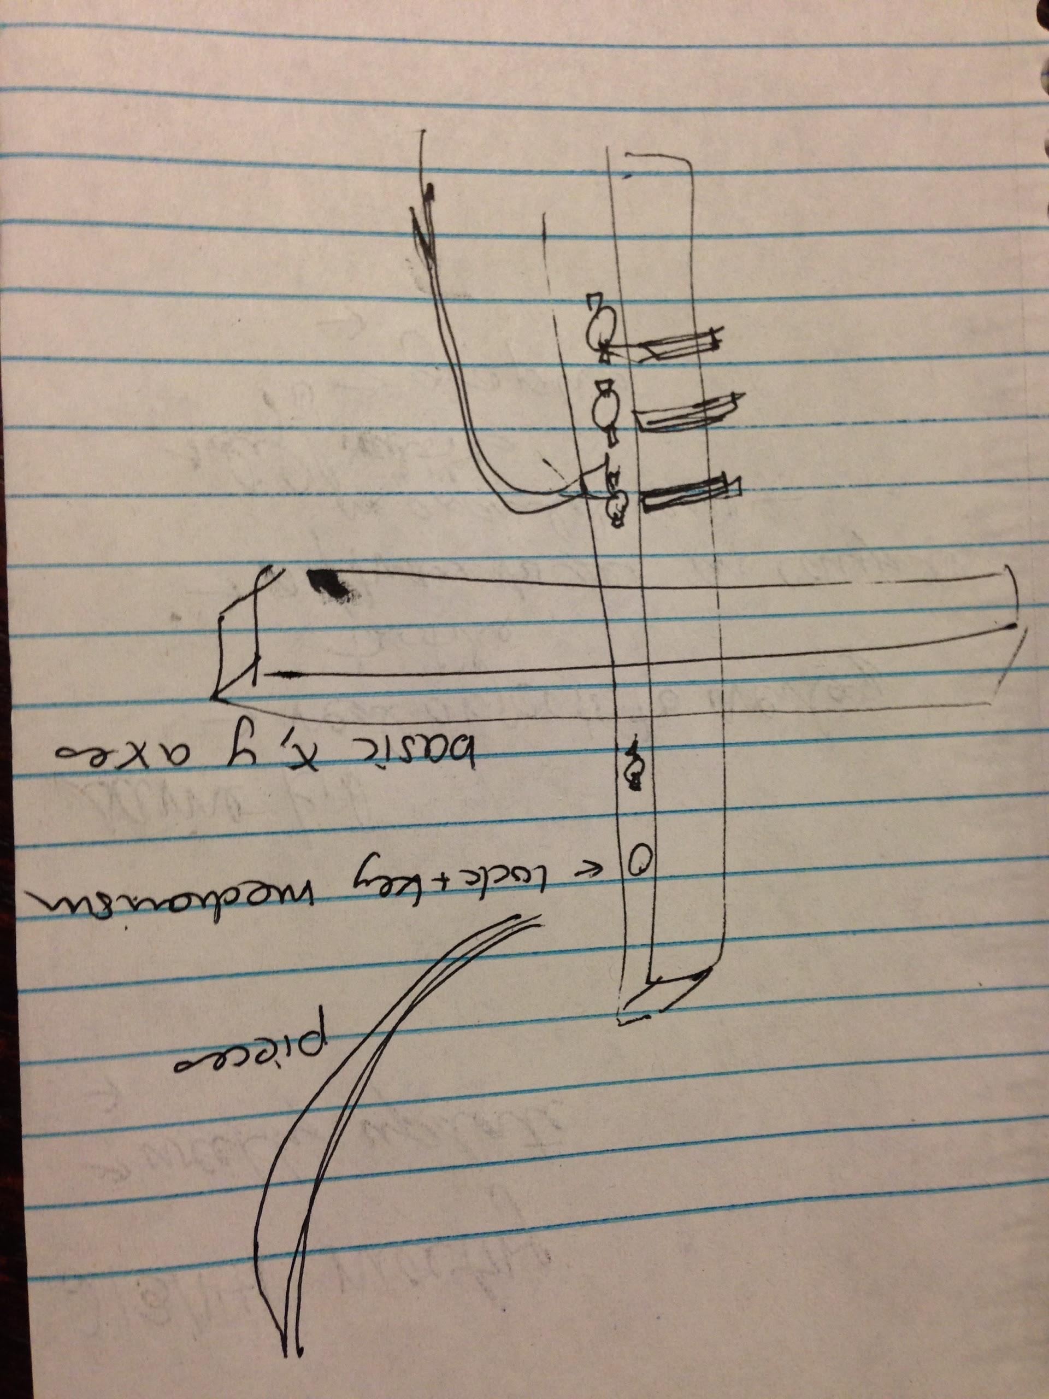
Figure 4. Examples of brainstormed concepts (A) 2D graphs and (B) 3D graphs.
The second idea was we explored was 3D graphs. A 3D bar graph could contain a grid with the x-axis in the plane of the table and the y-axis sticking out of the table. A bar whose length could be adjusted via sliding would fit onto the grid. We also discussed 3D graphs that depict surfaces such as 3D parabolas (Figure 4b). However, in both cases, we could not derive a logistically feasible way to design this using CAD software, and graphs of 3D surfaces are often not taught in high school.
We then proceeded to exploring the field of biology. Recalling our conversation about the SURG 101 anatomy class with the OAE, we considered producing detailed, life-size organ models. However, upon cross-checking this idea online with existing sources, we found human organ models that already exist on Thingiverse and an entire database of 3D body parts in OBJ format that could be converted to STL (Figure 5). Thus, we steered away from anatomy.
A. 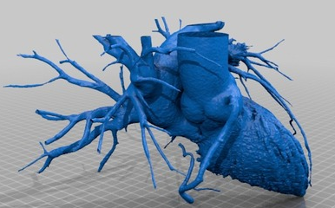 B. 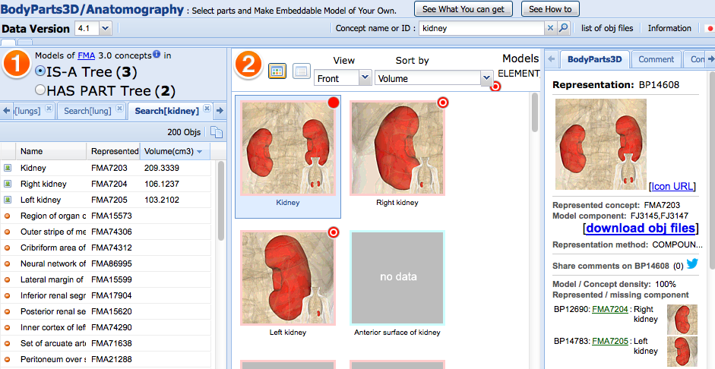
Figure 5: (A) human heart with vasculature, design from Thingiverse. (B) 3D-printable organ sample (Thingiverse, Thing 172862, BodyParts3D)
We then considered producing biological objects that exist on a microscopic scale. DNA has a unique helix structure, which would be difficult to represent using a tactile graphic. However, since 3D DNA helix models exist on Thingiverse, we wanted to take this idea a step further and convey not only DNA structure, but also function. The Central Dogma of biology, which is the conversion of DNA to RNA to protein, is a fundamental biological process and a standard component of high school biology classes nationwide. Students traditionally learn this via complex textbook diagrams (Figure 6), which challenges students with a visual impairment.
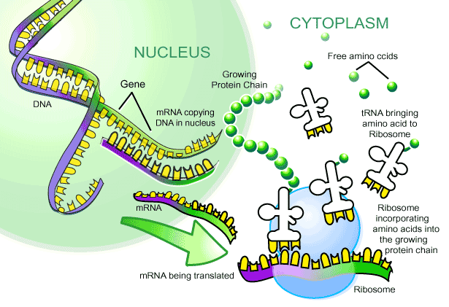
Figure 6. Textbook-style image explaining DNA transcription and RNA translation into protein, known more commonly as the central dogma of molecular biology. (www.montville.net/Page/4177)

Solidifying our design
Our specific design differs from current models on Thingiverse and other websites due to its interlocking pieces that simulate actual biological processes that happen on a nanoscale. Current models do not show the process of transcription and translation, only the products of such processes. Further, as this is an active process, it involves moving parts that allow us to capitalize on the functionality of 3D-printed, manipulable objects.
The process of transcription first involves DNA conversion to mRNA using an RNA polymerase. The mRNA is then translated into a protein using a ribosome and tRNA. We decided to design a simplified version of this process (high school level) through the design of 4 parts: DNA, mRNA, ribosome, and tRNA. Our preliminary digital and paper prototypes are shown in Figure 7.
A. 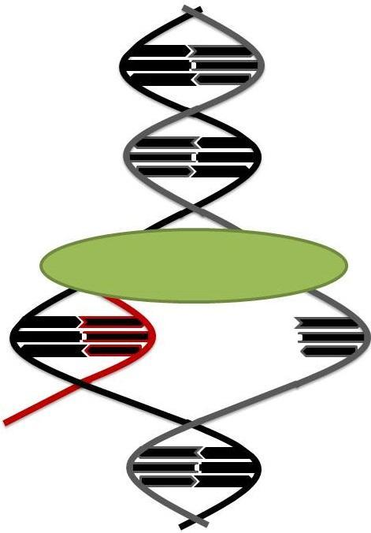 B. 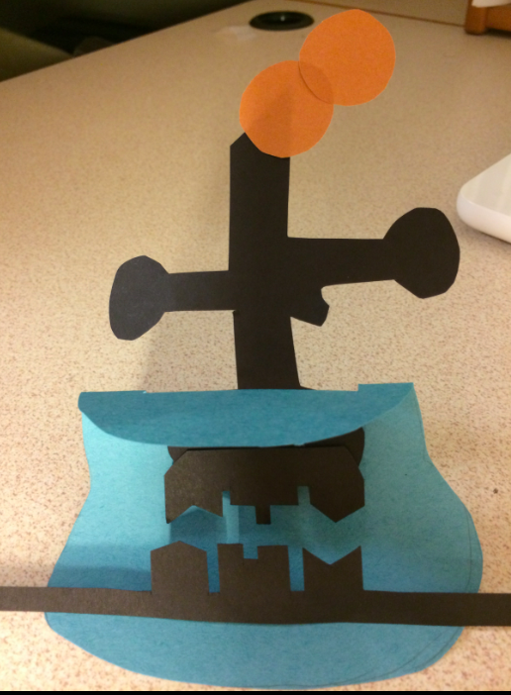
Figure 7. Sketches and paper prototypes of (A) DNA transcription and (B) RNA translation created by team members Shaheen (A) and Maya (B).
Following the preliminary prototypes, we drew detailed sketches of our parts including the actual dimensions (Figure 8). This was a key step before attempting CAD modeling to assure proper scale, especially since the model involves interlocking pieces.
A. 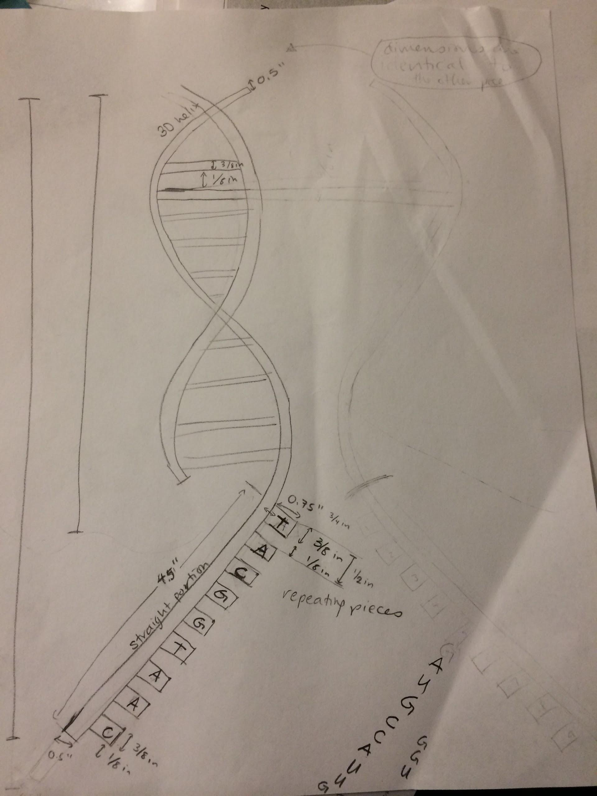 B. 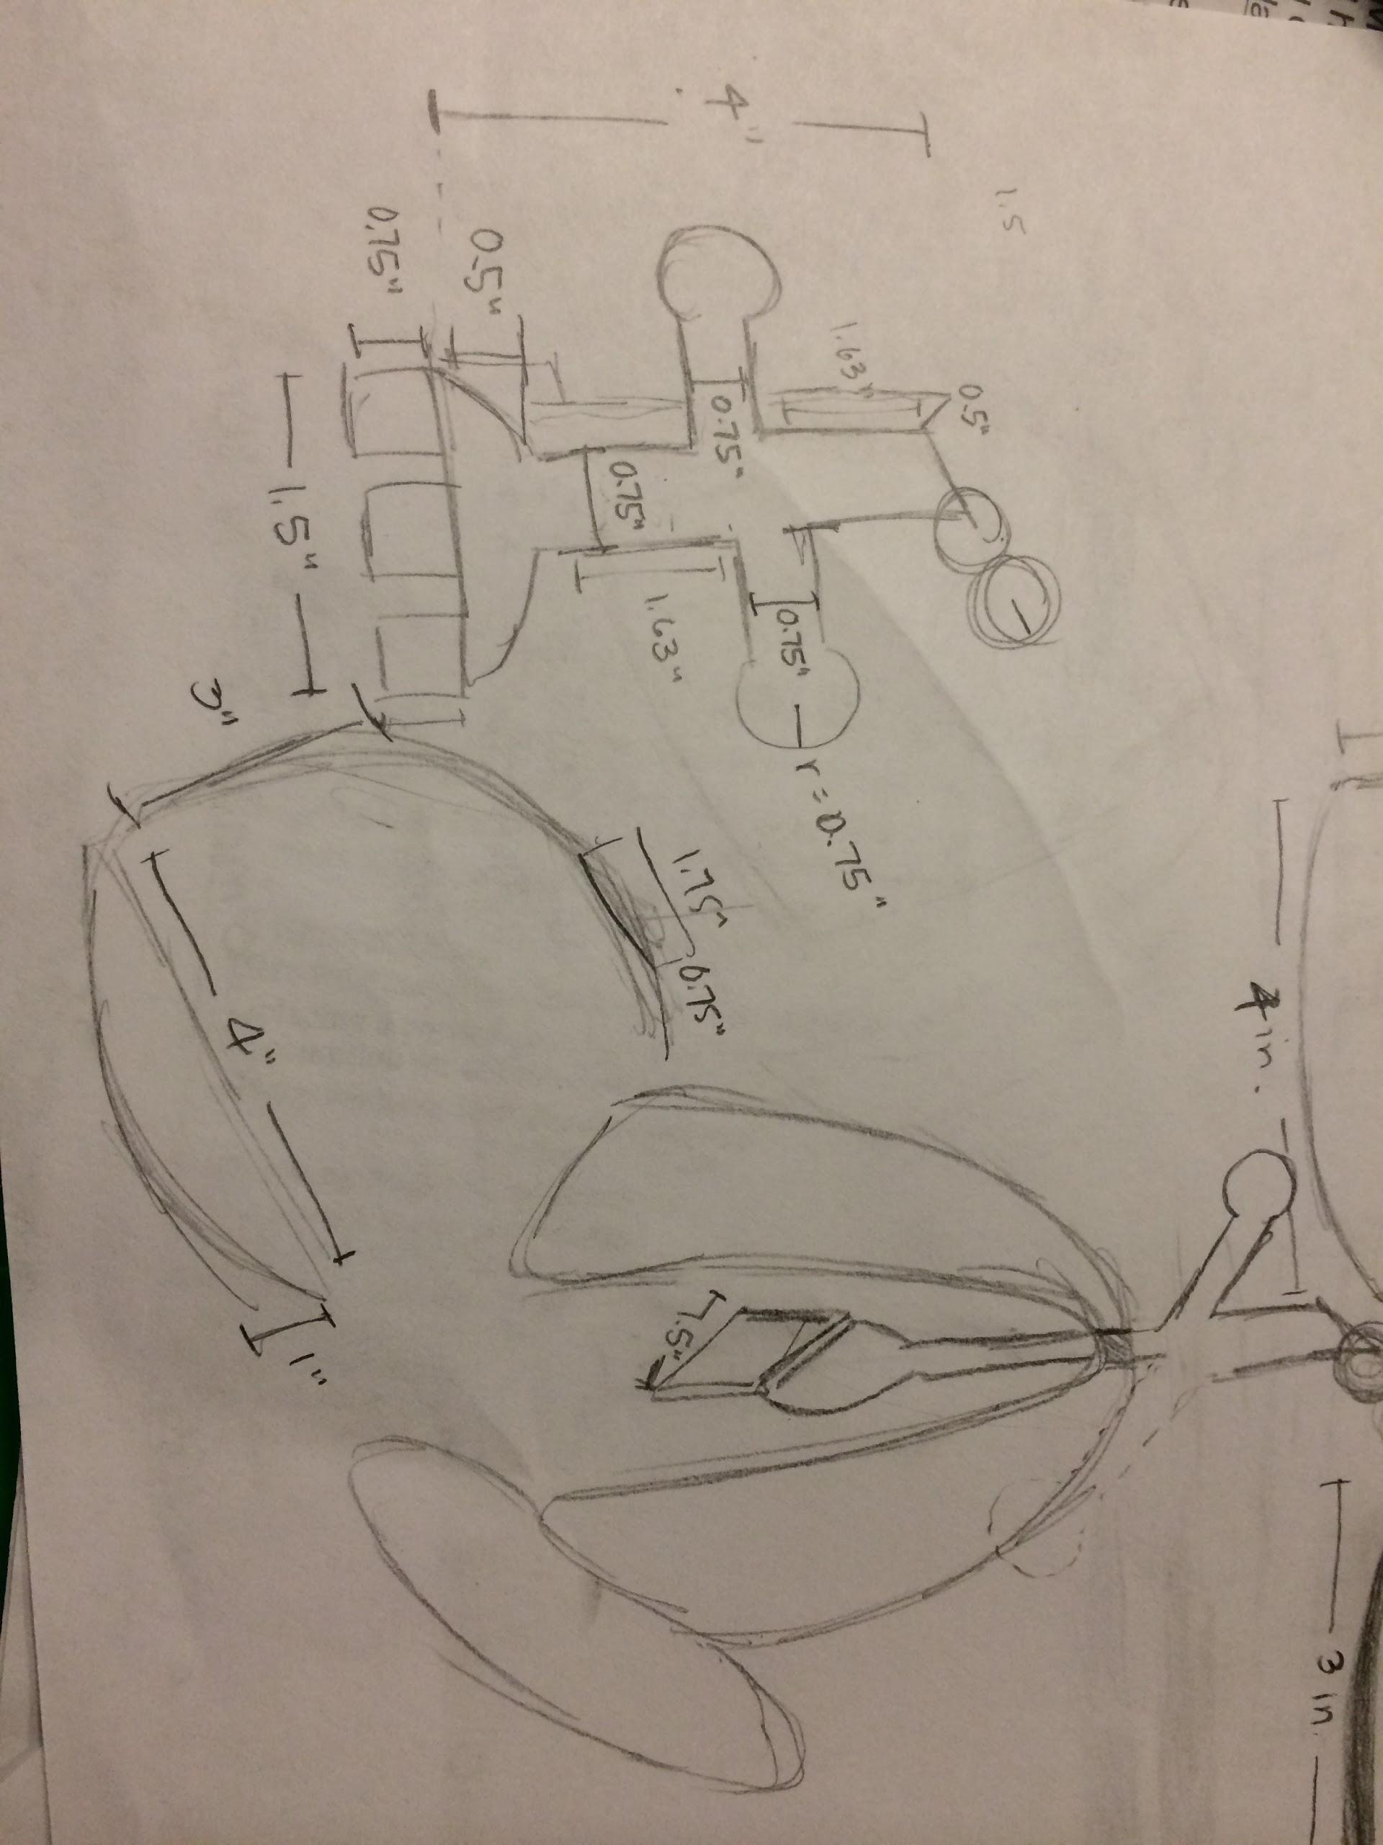
Figure 8. Sketches of parts to be designed in SolidWorks, with detailed dimensions. Designed by Shaheen for DNA transcription (A) and Maya for RNA translation (B).
Designing and Printing
Developing and fabricating our DNA transcription and RNA translation designs was initially attempted using the software SketchUp. However, this software lacked the necessary features for proper prototype design. For example, cutting pieces out of features and creating a spiraled 3D helix were incredibly difficult. We then switched to using the SolidWorks software, which presented its own set of challenges for first-time users, but the optimal size, shape, and configuration for 3D printing was finally achieved. The design process in SolidWorks first involved creating “parts.” Each codon, the DNA helix, mRNA strand, ribosome, and tRNA was each made as separate parts, an example of which is shown in Figure 9. These parts were then assembled in the proper orientation, also in SolidWorks (Figure 10). Once completed, the STL files were sent to Michael Flynn at the Stanford Product Realization Lab to obtain a price quote. The assemblies were scaled and modified to meet price specifications, and the objects were printed with Michael’s assistance. The parts were surrounded by a block of wax after emerging from the printer, which was melted in an oven and scraped off to produce the final product.
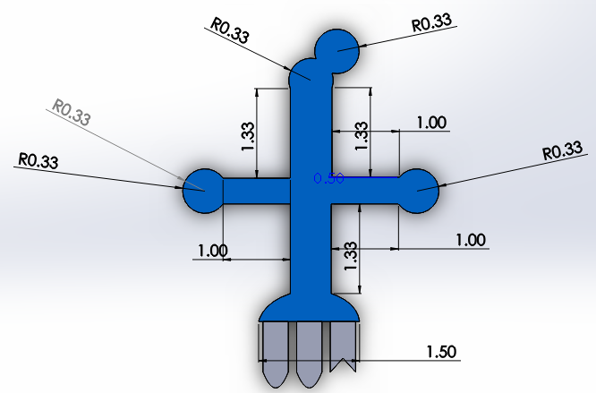
Figure 9. Putting together the tRNA assembly in SolidWorks, created by Maya and Ayna.
A. 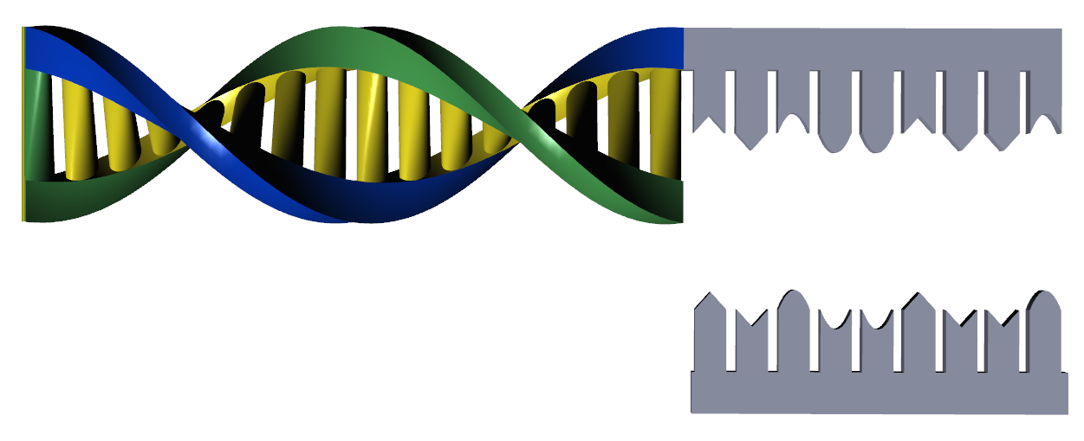B. 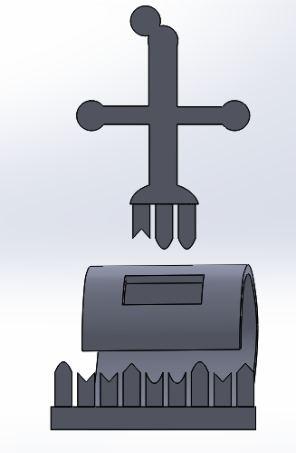
Figure 10. Final SolidWorks designs showing (A) DNA transcription and (B) RNA translation developed by all three team members.

Results
The final products consist of four 3D-printed pieces--a DNA helix, mRNA, ribosome, and tRNA (Figure 11). Each piece was printed using a 3D Systems ProJet 3500 HD printer owned by the Stanford Product Realization Lab. This printer uses multi-jet modeling (MJM) technology, and the objects are made of VisiJet Crystal material, similar to acrylic.
The process of transcription and translation can be described using our teaching aid as follows: The DNA helical portion (Figure 11) allows students to feel this unique helix shape, with the backbone consisting of phosphate and sugar groups. The pieces connecting the helical backbone represent nucleotides, which contain the “code” of genetic material. The straight portion of the DNA shows what happens when DNA unwinds in preparation for transcription. At this point, the RNA polymerase (not included for simplicity) adds complementary nucleotides to the DNA, producing a strand of mRNA that perfectly interlocks (Figure 12a). The mRNA detaches from the DNA, and the ribosome attaches to the mRNA. A tRNA containing a complementary codon to the mRNA bring along its corresponding amino acid (Figure 12b). This process of tRNA introducing amino acids repeats itself until a chain of amino acids (a protein) is formed.
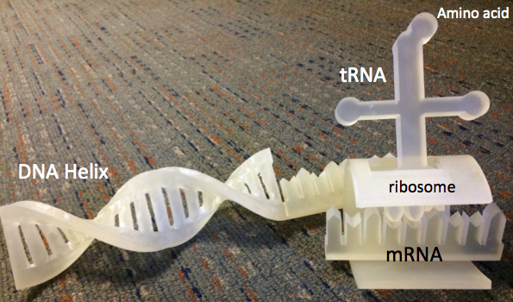
Figure 11. The final prototype!
A. 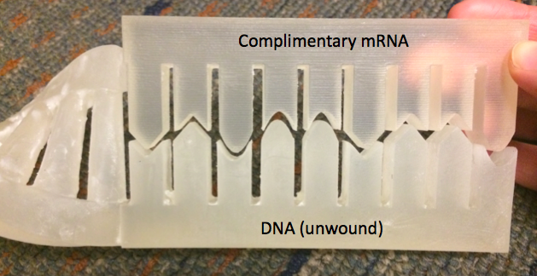 B. 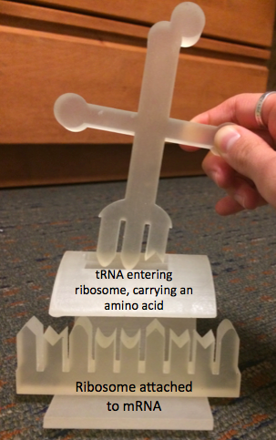
Figure 12. (A) mRNA synthesized complimentary to DNA. (B) tRNA entering the ribosome to deliver an amino acid that will contribute to the protein chain.

When designing these models, we had to ensure biological authenticity and that the parts were movable enough to explain a process, but solid enough to not fall apart in a student’s hands. The interlocking and manipulable parts produced allow students to actively engage with this molecular process. Further, the parts are durable, so they can be re-used multiple times. The pieces also fit comfortably in one’s hand, with the DNA helix being approximately 12” long, and the tRNA, mRNA, and ribosome, when assembled, having a height of about 7”. The set is of adequate size such that students can feel and interact with each feature on the pieces, and yet the entire product can easily fit on a desk. The nucleotides attached to the DNA/RNA backbone have clearly defined edges that allow the complementary shapes to be matched. Lastly, the advantage of designing an object for 3D printing is that we have the SolidWorks file that can modified and re-printed as needed, without having to re-make an entire teaching aid as would be the case with tactile graphics.
Although we did not have time to seek formalized user feedback, informal discussion with a blind student in our class was very positive. After feeling the DNA helix, he said he finally understood what the shape of DNA is, which is something he had never experienced before. Moving all of the parts in the correct orientation was a bit of a challenge, but something that can be improved with a formalized explanation of the entire process and when sitting at a desk, which doesn’t require holding all the objects at once. He also was able to feel the interlocking of the nucleotide pieces, which he found to be very useful. While preliminary reviews seem positive, more user feedback is necessary to get a sense of the merits and drawbacks of our design.
Further evaluation of the efficacy of our prototype is summarized in the table below:

Topic | Team Evaluation
Safety | These pieces are sturdy and would not pose initial risks to users. Rigorous mechanical testing would be necessary to assess fragility during extensive use.
Reliability of pieces  fitting together | The DNA and mRNA fit together perfectly, as do the mRNA and tRNA.
Size of pieces  and overall prototype | Due to size constraints in the 3D printer and cost limitations, this prototype was much smaller than we envisioned. All the pieces currently can fit comfortably in a student’s hand, but students can still interact with each feature. Ideally the prototypes would be blown up to at least double the size, such that students can still interact with the pieces and not worry about accidentally losing small items like the mRNA.
Biological correctness | DNA and mRNA are biologically correct, to the best of the team’s scientific knowledge and research from scientific papers and textbooks. The tRNA and ribosome pieces were liberally modified to enable student understanding rather than biological correctness. We deliberately did not create an RNA polymerase, a missing component in DNA transcription, to enhance student understanding, since RNA polymerase and ribosome wholly encompass the genetic material and cover the key components (DNA-mRNA and mRNA-tRNA) that link together and match.
Simplicity | The design is relatively simple and easy to explain and understand.
Cost | High. This small prototype cost $200 solely due to the volume of material required to print. Costs for teachers would include the 3D printer itself, which would vastly impact their budget for other, necessary materials in the classroom.
Ability to enhance  understanding  of biological concepts | It could be used in the classroom for students with and without visual impairments.
Appropriateness of 3D printing technology for creation  of this product | The prototype is much better at conveying the scientific concepts than a flat 2D image in a textbook or a tactile graphic.
Potential integration  of this prototype  with current teaching  techniques | A low-cost variant of this prototype could be integrated into every science classroom due to its ease of comprehension and ability to convey complex material in an easy manner, better than current teaching methods.

Budget
We spent our entire $200 budget to print our first prototype on the 3D printer in the PRL.

Discussion and Next Steps
Our project involved several challenges. First, the SketchUp software lacked key features for prototype design, while SolidWorks was user-unfriendly and required a large amount of time to learn mechanisms for prototype design. During the course of prototype design, the team questioned whether teachers would actually design their own devices or modify files downloaded from the Internet for use in the classroom. A fully-functional repository of pre-designed files and user-friendly videos or manuals on potential design modifications would alleviate this issue quite satisfactorily.
Printing these objects in 3D required 26 hours of printing time and $200 for this scaled-down prototype, with multiple design changes to fit the machine. Further developments in 3D printing technology are clearly necessary to enable the use of 3D printers in the classroom on a regular basis.
To refine our project, it would be useful to assess our designs with students who are visually impaired at the California School of the Blind (in Fremont) and at Jordan Middle School (in Palo Alto). During ideally 30-minute to 1-hour interviews with students and teachers, our criteria for successful prototyping would include the following questions for our interviewees and testers:
Topic | For students with visual impairments | For teachers
Original understanding / teaching | What do you know of DNA transcription and RNA translation before using the product? | How do you teach DNA transcription and RNA translation currently? What models or teaching techniques, if any, do you use for students with visual impairments?
New understanding / teaching after using the prototype | What do you know of DNA transcription and RNA translation after using the product? Has your understanding of these biological processes changed having used this product? | Would you use this in the classroom for teaching students without visual impairments? Students with visual impairments?
Use in teaching | Do you understand the product?  Does the concept of separating and combining parts aid in your understanding?  Would you use this in the classroom during a lecture? | Do you understand the product?  If you had access to a 3D printer in your classroom, would you print this out and use it?
Use at home | Would you use this at home to study for your biology exams?
Editing | What parts worked for you? What would you recommend changing?  Would you use the SketchUp software to edit this design or make additional pieces to use with this product? | What parts worked for you?  What would you recommend changing?  Would you use the SketchUp software to edit this design or make additional pieces to use with this product?
Self-printing | If you had access to a 3D printer at a local library for a small fee, would you print and use it?  What is the maximum fee you would pay for this? | If you had access to a 3D printer at a local library for a small fee, would you print and use it?  What is the maximum fee you would pay for this?
Concerns |  | Is loss of individual pieces a concern?  Would these pieces be a safety concern at all?
Other features | Would addition of Braille labeling on each piece enhance your understanding of each piece or of the overall product?  How about audio explanations with the product? | Would coloring and/or labeling these pieces help you use these pieces in the classroom?  How about interchangeable pieces (of codons G, C, T, and A within DNA and RNA)?

Though our evaluation of this first prototype is incomplete, we have already identified several areas within which we can create a better beta prototype. Braille labeling of each piece, along with audio files to explain the scientific concepts, would add additional educational support for students with visual impairments. Interchangeable codons and multiple tRNA could turn this product into an educational game to choose the right pieces to complete the scientific process, and allow teachers to encode specific proteins like keratin (hair) for students to further engage with the lectures.
More generally, the team has decided that with all of these challenges to 3D printing, it would not be the best use of our time to continue designing individual objects. Instead, we would like to work with Benetech on their online repository and work with people from Thingiverse, the community, teachers, and students to submit their designs to Benetech. The Benetech representatives could then refine the designs, standardize them for teachers, and add Braille as necessary.

Steps to Product Commercialization
The technical requirements in the production of a 3D printed learning object involve multiple levels of technicality. First, the necessity of using CAD software is crucial in creating an object. There must be access to CAD software through which teachers can at least download and manipulate a design, even if they do not create it themselves. Then, the object must be printed. Today, 3D printers are extraordinarily large and expensive, if you were to purchase the type necessary to offer granularity useful to visually impaired students. Printers like MakerBot, even though they are the main force behind the campaign of a ‘3D printer in every classroom’, are not large enough and high quality enough to product products that would be tactilely relevant to visually impaired students. The commercialization of a venture like this heavily depends on 3D printer technology, and the availability of it in every classroom, which is out of the bounds of Benetech’s mission. However, Benetech would have to create a repository of objects that could be easily accessed and understood by teachers around the world. The crucial part of commercialization is ensuring that teachers would know how to transfer a downloaded object into the printer, and how to then take the object out of the printer, in one coherent learning manual. Because each classroom will have different tools available, and because Benetech only is exploring the actual object design, the process has potential to become very complicated.
Additionally, when considering go to market strategy, although Benetech has a stream of users, we would have to understand how to best communicate this novel learning engine and opportunity. Obviously, this learning opportunity is not restricted to students with visual impairments. Students with no visual impairment can still find useful a 3D printed object when explaining a topic. The key component would be to figure out the best way to market this vertical. Our team can envision that Benetech uses this vertical to become a brand name in educational tools for students worldwide, and use that notoriety to propel their brand and mission to all types of people.

Acknowledgements
We would like to thank Dave Jaffe, Professor Drew Nelson, Margaret Mongare, and Dr. Proadpran Punyabukkana for their guidance. Anh Bui, Adam Bernstein, Kristina Cohen, Gerardo Capiel, and Cherie Miller from Benetech have provided invaluable advice and guidance on this project.
We would also like to thank our many interviewees: Kartik Sawhney at Stanford; Nicole Torcolini formerly at Stanford and now at Google; Anne Peterson, Deborah Ting, and Alice Wong at the Stanford Office of Accessible Education; Ann Duesterberg, Leslie Goldman, and Robin Levy at Jordan Middle School; Jerry Kuns at the California School of the Blind; Gustav Knape, who did his graduate thesis on 3D-printed models for blind students; and Ting Sui a PhD student at UC Berkeley who teaches students with visual impairments and is a research consultant for DIAGRAM.
A final thanks to the shop Teaching Assistants and Michael Flynn in the Product Realization Lab for their extensive guidance.

References
American Printing House for the Blind, Inc. Web. Accessed Feb 18, 2014. <www.apg.org>
Benetech: Technology Serving Humanity, 2014. Web. Accessed Feb 18, 2014. <benetech.org>
Bobnar, A. “APH Quota Funds: How to Access Free Educational Materials for Blind and Deaf- Blind Students.” 2013. Web. Accessed Feb 18, 2014. <nfb.org/images/nfb/publications/fr/fr32/3/fr320315.htm>
BodyParts3D. The Database Center for Life Science. <http://lifesciencedb.jp/bp3d/?lng=en>
Bouvry, Geraldine. “3D printing could bring touchable painting to the visually impaired.” 3ders.org.<www.3ders.org/articles/20130409-3d-printing-could-bring-touchable-painting-to-the-visually-impaired.html?utm_source=dlvr.it&utm_medium=twitter>
“Central Dogma of Molecular Biology.” Wikipedia. Jan 28, 2014. Web. Accessed Mar 8, 2014. <en.wikipedia.org/wiki/Central_dogma_of_molecular_biology>
Computer Science Hub. “Photo of the Day: A Visual History of 3D Printing.” Medical Design Technology, Feb 12, 2014. Web. Accessed Feb 18, 2014. <www.mdtmag.com/news/2014/02/photo-day-visual-history-3d-printing>
Cryer, H. “Teaching STEM subjects to blind and partially sighted students: Literature review and resources.” RNIM Centre for Accessible Information, May 16, 2013.
DIAGRAM Center: A Benetech Global Literacy Initiative, Digital Image and Graphic Resources for Accessible Material. Web. Accessed Feb 18, 2014. <diagramcenter.org/>
Healthphysics, Thingiverse #172862. “Heart chambers and vascular tree from CT angiogram” <http://www.thingiverse.com/thing:172862>
“Improving Undergraduate STEM Education.” National Science Foundation. Web. Accessed Feb 18, 2014. <www.nsf.gov/funding/pgm_summ.jsp?pims_id=504976>
Jones GM, Broadwell B. “Chapter 12: Visualization without Vision: Students with Visual Impairment.” Visualization: Theory and Practice in Science Education, 2008: pg. 283-294.
McCue, TJ. “3D Printing Will Transform Education.” Forbes. Nov 1, 2011. Web. Accessed Feb 18, 2014. <www.forbes.com/sites/tjmccue/2011/11/01/3d-printing-will-transform-education/>
Moon NW, Todd RL, Morton DL, Ivey E. “Accommodating Students with Disabilities in Science, Technology, Engineering, and Mathematics: Findings from Research and Practice for Middle Grades through University Education.” Center for Assistive Technology and Environmental Access, College of Architecture, Georgia Institute of Technology. SciTrain: Science and Math for All, 2012.
“Research in Disabilities Education (RDE).” National Science Foundation. Web. Accessed Feb 18, 2014. <www.nsf.gov/funding/pgm_summ.jsp?pims_id=5482>
Weaver D, Villard R. “Hubble Image Becomes Tactile 3-D Experience for the Blind” HubbleSite News Center. <hubblesite.org/newscenter/archive/releases/2014/03/full/>

Appendix 1. Resources for teaching STEM to blind/partially sighted students.
Source: Cryer, H. “Teaching STEM subjects to blind and partially sighted students: Literature review and resources.” RNIM Centre for Accessible Information, 16 May 2013.
1.1 Practical guidance/resources
UK
- THE STEM professional development e-learning package: a collection of resources aimed at higher education professionals to support students with visual impairments in STEM subjectsstem.ecs.soton.ac.uk/
- The STEM Diversity and Equality Toolkit: resources to help promote STEM subjects to 11-16 years olds from diverse backgrounds (including those with disabilities). www.stem-e-and-d-toolkit.co.uk/home/welcome-the-equality-and-diversity-toolkit
- STEM disability committee (STEM-DC): a group made up from various UK professional bodies in STEM subjects with a special interest in promoting STEM, and improving access to STEM for disabled people. Website includes information on STEM-DC projects as well as a portal with links to information for students, teachers, employers, researchers and so on.www.stemdisability.org.uk/default.aspx
- Disabilities Academic Resources Tool (DART): An online resource aiming to help educational institutions to assess the accessibility of their provision for disabled students and to provide advice on improvements. Includes detailed case studies of students with disabilities’ experiences of higher education and an auditing and diagnostic tool to suggest accessibility improvements. Project completed December 2005, based at Loughborough University (UK). dart.lboro.ac.uk/index.htm
- QATRAIN2 – a web-based resource aiming to enable disabled learners to participate fully in Vocational Education and Training. Aimed at teachers/trainers and those involved in course planning/assessment. Includes resources relating to numeracy.uk.qatrain2.eu/
- Load2Learn: Learning resources in downloadable, accessible formats for students who have difficulty reading standard printed books, including books and images, and training and guidance for staff in creating and using accessible curriculum resourcesload2learn.org.uk/
- UK Association for Accessible Formats (UKAAF) guidance on producing accessible materials, including guidance on describing various kinds of imageswww.ukaaf.org/formats-and-guidance
Rest of world
- Access2Science - a website run by blind volunteers working in STEM fields offering practical information and links to accessible materials (USA).www.access2science.com/index.html
- SciTrain – website offering free online training courses in making high school level science/maths/computer science accessible to students with disabilities (USA).www.catea.gatech.edu/scitrain/index.php
- SciTrainU – website offering free online training in making university level STEM subjects accessible to students with disabilities. Also includes a searchable knowledge base with links to many articles on this subject (USA).www.catea.gatech.edu/scitrainU/index.php
- Guidelines and Standards for Tactile Graphics (2010): a comprehensive manual developed in North America for the production of tactile graphicsbrailleauthority.org/tg/web-manual/
- Tactile graphics – A how to guide: guidance on the production of tactile graphics (USA)www.tactilegraphics.org/index.html
1.2 Technical/Products
Rest of world
- Touch Graphics STEM binder: a kit combining high quality tactile graphics and a talking pen device which gives relevant audio information when touched onto the graphics.www.touchgraphics.com/research/STEM.html
1.3 Research/development
UK
- Links to articles in Maths, Stats and Operational Research (MSOR) Connections (newsletter of MSOR network) on supporting students with disabilities (UK). www.mathstore.ac.uk/node/126
- Investigating the Potential of 3D printing for creating tactile objects for use in education: report in preparation from RNIB’s Centre for Accessible Information. Contact accessibleinfo@rnib.org.uk

