3D Printing for Accessible Materials in Schools – Final Report
Yue-Ting Siu, TVI
UC Berkeley & San Francisco State University

Date: May 24, 2014

Introduction

This final report documents work carried out by Yue-Ting (Ting) Siu on behalf of the DIAGRAM Center to conduct field research in order to provide relevant information regarding current practices in three-dimensional (3D) printing to support students with visual impairments.
Preliminary research was carried out in Fall 2013 via an online survey that provided general information regarding current uses of, and access to 3D printing by professionals who are responsible for providing tactile materials to students with visual impairments (Appendix A). Ensuing research focused on identifying classroom needs for 3D printed materials, challenges to implementing 3D printing in the classroom, and identifying successful models of implementation.

Executive Summary

The primary research agenda of the project was to identify current uses of 3D printing with students with visual impairments, challenges with implementation in the classroom, and propose solutions to address barriers in using this technology.
The initial online survey included a sample size of 163 respondents. Although this sample size does not approach the true number of people working with this population of students, it encompassed people dedicated to providing accessible materials, particularly 90 TVIs whose primary responsibility was to ensure appropriate accommodations and education in the learning environment.
Despite these respondents demonstrating a higher level of technology use simply by accessing this online survey, a very small number reported direct experience with 3D printing, and many were unfamiliar with using 3D printing to support students with visual impairments at all.
The greatest challenge to these respondents’ use of 3D printing for accessible materials was access to a 3D printer, and lack of resources and support in using this tool in the classroom. These barriers severely limited the abilities of professionals to explore the potential applications of this technology.
The final part of this project focused on talking to professionals with specific expertise in using 3D printing to create materials for students who are visually impaired. Information was gathered via a combination of in-depth formal interviews, phone calls, email, and a long answer questionnaire. More general information regarding the prevalence and uses of 3D printing in the general community were gathered via academic and news articles, and social media such as twitter and blogs. Lastly, 2 case studies provided models for successful implementation of 3D printing to support students with visual impairments in the classroom.
3D printing was identified as part of a suite of other tools used to provide accessible materials, including: pre-teaching, Braille, tactile graphics, and image and video description. The main advantages of using 3D printing were: bringing imagined creations to life, ability to customize devices, enhancing the learning of all students in a classroom, and use of the technology by anyone to create an accessible environment. Challenges of accessing and implementing 3D printing, and related training echoed findings from the preliminary research. Several resources were identified to remove these barriers to the technology: the development and curation of repositories to streamline availability of 3D designs, availability of outreach activities in the community to support training initiatives, and improving affordability and accessibility of the equipment for inclusive use.

Activities Completed in Final Project Phase

Background research

A combination of academic and news articles, blogs, and press releases were reviewed to determine the prevalence of 3D printing in mainstream environments. Given the overwhelming amount of anecdotal information on the technology in many sectors (including medicine, science, museums, art, food science, assistive technology, and furniture), Appendix B lists a selection of only those articles focused on 3D printing in k-12 and post secondary education, and community-based education programs in libraries and museums. Many of the educational applications of 3D printing are in science, technology, engineering, and math (STEM) areas. There are also a number of initiatives to develop curriculum for students learning how to design and 3D print models for varieties of uses. Several articles report on collaborations between 3D printer and other technology companies, international and domestic schools, public and private schools including programs for the blind, and libraries and museums. The ultimate goal of these collaborations is to increase access to and uses of 3D printers in schools.
A more limited number of scholarly articles (8) report pedagogical uses of 3D printing as a teaching tool in general education classrooms. 6 of these articles focus on students without disabilities’ use of 3D printers to create their own classroom materials, and how the process of conceptualization, design, and fabrication of models ultimately increased comprehension of academic content. The remaining 2 describe how 3D printing has been used to support chemistry instruction for a blind student.
Given the breadth of uses, this research reports on 3D printing specifically within the scope of providing accessible materials for students with visual impairments in the classroom, and recommendations for inclusive implementation and access.

Interviews

12 in-depth interviews were carried out with follow-up contact by phone and/or email. An additional 5 interviews were carried out informally via long answer questions that were responded to via email. The purpose of these interviews was to gather qualitative data from people who were currently using 3D printing to benefit students with visual impairments. Information included challenges and benefits of this technology, and suggestions for future practice.

Demographics

The 17 people contacted included representatives from schools for the blind (4), professional organizations affiliated with blindness and visual impairment (5), public schools (3), and universities (5). All interviewees were invested in 3D printing for the creation of accessible materials, although the extent of technological and pedagogical expertise varied. All of the interviewees were directly involved with using the technology in their respective locations, and included general or special education teachers, assistive technology trainers, technologists, librarians, or students themselves.

Questions

The following questions were asked:
- Tell me how you have implemented 3D printing in your school
- What is your prior experience using 3D printing, and/or with creating accessible materials for students who are visually impaired?
- What types of things do you 3D print for students [with visual impairments]?
- How has 3D printing changed how you provide accessible materials to students [who are visually impaired]?
- What are some of the greatest challenges you have experienced in the process of using 3D printing for students?
- How do you access 3D printing:
  - Where is the machine located?
  - How easy is it for you to use it?
  - How many 3D printers support how many students?
- How do you see 3D printing potentially fitting into the workflow of providing accessible materials to students with visual impairments?

Findings

Several recurring themes were observed across all interviews. This was surprising, given the differences in experience using technology, levels of involvement working directly with students with visual impairments, and amount of time allocated to learning and using the technology.

- Technology proficiency. Regardless of prior technological expertise, all interviewees cited a significant learning curve in using 3D printing technology. Of the people who considered themselves “technologists”, all admitted the difficulty of mastering the technology associated with 3D printing, and people who were less technology savvy mentioned issues with troubleshooting problems that arose. Interestingly, even the more experienced “technologists” did not consider themselves to be experts at using 3D printing, and reported challenges in troubleshooting the technology. Challenges included issues associated with the 3D printers, design software to create files for 3D printing, and usability of existing files to print 3D objects.
- Access to a 3D printer. Direct access to a 3D printer impacted how often each interviewee used 3D printing, how well they had managed to learn the technology, and to what extent they used the technology as a teaching tool. In all of the cases where the 3D printer was located in an administrative office or instructional technology department separate from the assistive technology and special education staff, the 3D printer was considered difficult to use, not implemented into instruction, and interviewees were unsure how to use it to enhance learning. Of the interviewees with direct access to a 3D printer, they provided the most specific recommendations for how this technology bridged gaps in the provision of accessible materials, consistently implemented 3D printed materials among other tools in the classroom, and were more likely to troubleshoot and overcome the technical difficulties of the technology.
- Access to resources. Access to resources for support was a determining factor in what device was chosen, what design software was used, and to what extent use of 3D printed materials were even used to provide accessible materials in the classroom. For example, the main reason staff at two different schools chose the 3D printer they did was because there was a physical location nearby where they could go to for immediate help and support. Interviewees overwhelmingly reported learning about 3D printing at a professional conference, yet those who remained unsure of exact uses and implementation were those individuals who struggled with consistent use of the tool with students.
- Accessibility of the technology itself. Accessibility of 3D printing was differentiated in two ways; procuring funding to buy a printer, and nonvisual use of the software and hardware by a user with a vision impairment.
  - With the exception of 1 interviewee who was an educator with a direct association with a 3D printer vendor, all interviewees had secured funding for only one printer. For school-based staff, the printer was so closely guarded that only 2 staff members had permission to manage and use the device. Almost all interviewees envisioned having at least 1 3D printer per classroom.
  - Several of the interviewees were themselves blind, and relied on a command line interface to access design software, and/or sighted assistants to complete projects. For less advanced students who are learning to use this technology for themselves, tools must be developed with accessibility at the forefront of the design to be truly inclusive of all learners.
- Collaboration. The most successful uses of 3D printing involved collaboration with IT staff, or someone who provided the tech support and did the printing according to teacher specifications. In the instances where the teachers relied on the tech skills of someone else to use the printer, 3D printing did not happen when the tech support was unavailable. In cases where there was a 3D printer available but unused, there seemed to be a lack of training and information on how to use the printer and what to print.
- Inclusive learning benefits everyone. The most well-utilized cases of 3D printing in schools were those where interviewees reported the technology and materials concurrently benefitting students in general education. In these cases, the classroom teacher/professor was empowered to provide accessible materials to the student with visual impairments in the classroom while enhancing the learning of sighted students. Instead of relying on a specialist such as a teacher of students with visual impairments (TVI), classroom teachers felt like they had the skills to take ownership of teaching every student in their classroom.

Case Studies

Two sites were identified where 3D printing was used specifically to support students with visual impairments in the classroom. There were several similarities across both cases:
- Collaboration between general education teacher, and TVI or blind student
- On-site or easy access to 3D printer
- 1 3D printer = 1 classroom
- Used 3D printing to model microscopic objects
- Steep learning curve in using the 3D printer and also creating the .stl files
- Use of models benefitted both students who are blind and sighted classmates

K-12 public school

A series of phone interviews and email follow up with the AT specialist, TVI, and biology teacher provided information for the first case study.
Los Angeles Unified School District (LAUSD) is among the largest school districts in the country, and has its own department dedicated to supporting students with visual impairments. Among the staff of TVIs, orientation and mobility (O&M) specialists, paraprofessionals, and transcribers, there is also an assistive technology (AT) specialist who is dedicated to technology for students who are visually impaired.
The AT specialist had learned of 3D printing at a professional conference, and secured low incidence funding to purchase a printer. Together with a TVI who supported blind students in a public high school, they chose to purchase a Bukobot (Fig. 2) from a local store because immediate, on-site technology support would be readily available. The vendor, Diego Porqueras of Deezmaker, promised personal tech support, and has since been available as needed to help troubleshoot technical issues that arose. Local access to this technical support has been crucial in learning and maintaining the machine. The printer was purchased and introduced during the 2012-2013 school year, and is located in the district’s Braille Resource Center. Because the TVI was itinerant, he was able to access the printer between travel to and from different school sites. This TVI also has a high level of technical expertise, and prior experience using computer assisted drawing software.
The TVI and AT specialist chose to implement 3D printing in a high school where there were 2 blind students taking biology. The TVI worked closely with the students’ biology teacher to anticipate what upcoming lessons would cover, and what materials needed to be made accessible. Together, they determined that molecular structures would be better represented as 3D-printed objects, because verbal descriptions and tactile diagrams could not sufficiently convey the microscopic concepts (Fig. 1).
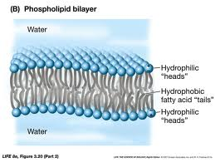
Figure 1. Phospholipid bilayer

Despite the technical background of the TVI and the AT specialist’s overall familiarity with various technologies, they both relied on the support of the 3D printer vendor to troubleshoot problems that arose. The TVI admitted to spending hours learning how to use the machine, and refining the design of objects. The opportunity to “fiddle” with the 3D printer and design software (OpenSCAD) ultimately enabled the TVI to create objects specific to his students’ biology lessons (Appendix C). Ongoing support of the vendor also enabled ongoing assessment of how well the technology was meeting the teachers’ and students’ needs, and resulted in the TVI trading in the Bukobot for the Bukito (Fig. 3). The change from a desktop 3D printer to a portable one will allow the TVI to continue designing and refining 3D-printed objects by ensuring access to a printer regardless of where he is assigned to teach. The TVI believes the use of 3D models can be crucial for blind students’ understanding of some concepts that cannot be adequately conveyed with a tactile diagram. Having the ability to 3D print onsite allows for these models to be immediately available at a more affordable cost than expensive, commercially available models.

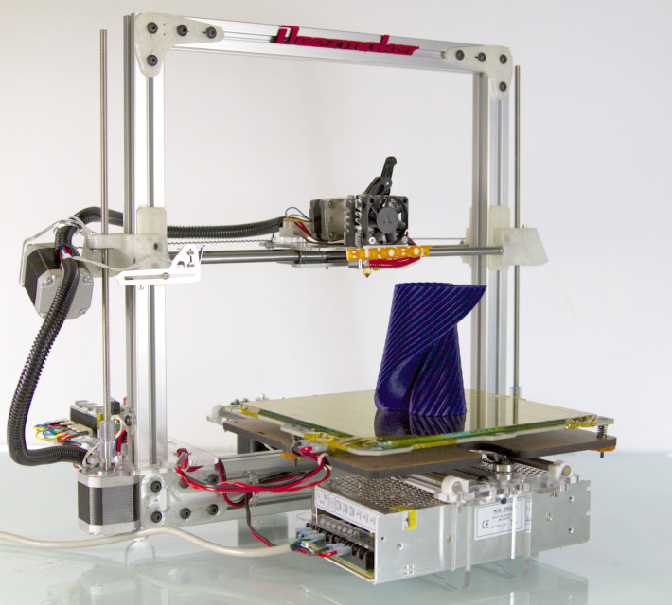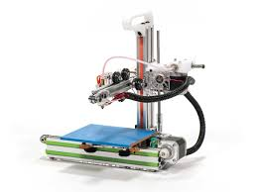
Figure 2. Bukobot Figure 3. Bukito

The time it required for the TVI to learn the technology was significant, and he relied mostly on information from the Internet to learn how to design and 3D print objects. At the time of this research during Spring 2014, the TVI had been reassigned to teach in a resource room, and unable to access the 3D printer at all during the school day since he no longer traveled to different sites. As a result, the TVI has had limited time to use the printer and create additional files for printing. He remains encouraged by the success of 3D printing in the previous school year; the biology teacher wholeheartedly embraced the 3D-printed models in her class, and found that all students benefited from the manipulatives. The teacher did not have existing models of the molecules in her class, and found that all students’ understanding of the subject was enhanced by the ability to interact and manipulate otherwise microscopic (and thus theoretical) concepts. The TVI has since committed to creating a nonprofit student organization within the school district to support a stronger 3D printing initiative. Together with the support of the biology teacher, they are able to justify ongoing use of the device because it is benefitting 350 students in general education that are taking biology, not just the 2 students who are blind.
Ultimately, the biology teacher, TVI, and AT specialist all envision 3D printing being integrated into classroom teachers’ curricular materials, and blind and sighted students working together to design and print their own creations. The AT specialist viewed the district’s availability of student computer programming classes as a potential collaboration to adopt student-wide and student-driven 3D printing activities.

Postsecondary education

Articles on the University of California, Davis website (http://ls.ucdavis.edu/mps/news-and-research/3-d.html) and 3 interviews via a long answer survey gathered information on this second case study.
In June 2010, a computational organic chemistry lab at the University of California, Davis purchased a Z-Corp 450 rapid prototyper (3D printer, Fig. 4) with support from the National Science Foundation (NSF), the UC Davis Math & Physical Sciences Dean’s Office, and the UC Davis Department of Chemistry. The machine was originally purchased to support a blind doctoral student conducting research in computational organic chemistry. The machine is housed in the lab, which is maintained and supervised by a team of graduate students. Members of the lab collectively help implement use of the 3D printer as a research tool for tactile graphics, molecular model kits, and with other software. The printer was used to print spheres (atoms), which were then connected by sticks (chemical bonds). Although the printer was capable of printing intricate objects with color, the models were ultimate brittle and difficult to handle in the finishing process. The machine was also largely inaccessible to the blind student.
In September 2013, the lab also purchased a Stratasys U-Print 1600 (Fig. 5), which produces objects in ABS plastic (less brittle). Although, the blind student is currently the only person using the 3D models for his research, he has found that interaction with the design of the models has likewise helped sighted students visualize molecular structure, and structure-function relationship.

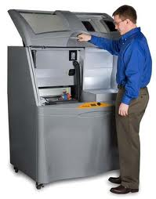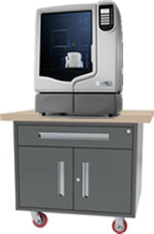
Figure 4. Z-Corp 450 Figure 5. Stratasys

One of the chemistry professors originally suggested 3D printing as a means to support this one blind student’s understanding of theoretical chemistry, and values the technology as a means to enable construction of more precise (and previously unavailable) models in the classroom. In the process of using the 3D printer, the blind student oversees calculation of the geometry of a particular molecule, then works with lab assistants to design the model using AsteriX structure extraction software. After sending the file to print, it takes about three to four hours to produce a fist-sized model (Fig. 6). The models include braille labels or are printed with unique textures to differentiate atoms within a molecule. Using the Z-Corp 450 printer, the blind student had to work with a sighted assistant to maintain and run the machine, and “finish” the models after printing; with the Stratasys U-Print 1600, he uses the printer mostly independently.

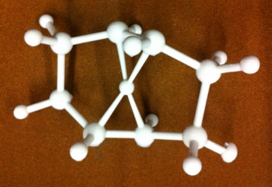
Figure 6. 3D-printed model of a molecule.

Currently, the lab has one working printer, and another that needs repair. The blind student’s greatest challenge in using 3D printing is that the printer itself is not accessible using screen reading technology. He and another lab mate otherwise reported it has been technically easy to learn, troubleshoot, and maintain with the help of assistants and lab members. Other lab mates emphasized the difficulty of creating the .stl files needed to 3D print molecules, especially in sizing the model components for readability.
Given the difficulty in designing the files for 3D printing, the lab members have collectively designed 20 objects, which are shared through the open source program AsteriX Structure Extractor. They otherwise envision having the files posted and shared freely from a university’s public domain server for other universities and schools to access. Provision of the files would then remove the burden of having to create the necessary .stl files, and educational institutions would only have to problem solve acquisition and maintenance of a 3D printer.
Lastly, the students in this case study agreed that 3D printing was an excellent approach to creating high-quality models that more tangibly represent molecular concepts. They posed that 3D printing can ultimately become cheaper and more relevant as more students benefit. The chemistry lab has already communicated about sharing this technology with other interested departments such as engineering and veterinary medicine.

Webinar

Although interviews were carried out with professionals specifically dedicated to meeting the needs of students with visual impairments, a 60-minute webinar attracted 298 registrants (157 attended live) from a variety of sectors including: special and general education, museum, library, technology, and accessibility.
The webinar was given to summarize the basic findings and data on 3D printing for accessible materials in schools, and serves as a resource for implementation and outreach. Models of implementation of 3D printing were offered via two case studies in high school and university settings, along with recommendations for community-wide resources to support this technology to serve all students.
Virtual handouts for further information were provided regarding existing hardware, software, lesson plans, and resources to support implementation of 3D printing for accessible materials in schools.

Discussion

3D printing is prevalent in the mainstream community, however it requires consideration in order to enable meaningful practice and implementation in the classroom environment. As reported in the preliminary survey, most professionals who specialize in supporting students with visual impairments lack information on how this technology is relevant to the provision of accessible materials, and seek information and resources. Although the samples included in the preliminary and follow-up studies are simply snapshots of the overall field, it is reasonable to anticipate that people who provide students with accessible materials in the classroom may benefit from ongoing support and training to implement 3D printing in the classroom.
Implementation challenges include access to a 3D printer and related technologies, training, and resources; technical expertise; and most importantly, time to learn and troubleshoot technical problems that arise.
Improving access to the technology by removing some of the barriers to its use might include streamlining the process to minimize technological challenges and encouraging outreach efforts to support training and provide resources. Other means of improved access include decreasing the cost of 3D printers, improving usability of existing tools, and advocating for more prevalent accessibility of 3D printing tools by the users the materials are meant to benefit. Many of the interviewees expressed visions of “1-click” use with minimal troubleshooting needed to operate a 3D printer. Most of the expert technologists interviewed agreed that having free and open access to repositories of .stl files would minimize a large challenge of using 3D printing technology. These are both excellent objectives that would significantly improve access to 3D printing by teachers who already have limited time to overcome the current learning curve of this technology (as reported in the preliminary survey).
The most successful models of implementation were those that included collaboration among general and special education staff, the students who benefited from 3D printed materials, and community resources. These partnerships allowed TVIs to focus on the pedagogical needs of learners with visual impairments while simultaneously leveraging materials that benefited students with and without vision impairments. In this way, uses of 3D printing naturally led to adoption by general education teachers and students to support every student in a school regardless of ability. In both case studies, the students with and without visual impairments were also involved in creating their own learning materials. Considering the prevalence of student-centered curricula and initiatives reflected in the articles included for background research, considerations for universal and inclusive access to 3D printers and accompanying software should be equally emphasized.

Recommendations

Based on the themes prevalent across many of the interviews, the following recommendations were developed to address the challenges of implementing 3D printing for accessible materials in schools:
- Collaborate with instructional technology and computer programming departments, and general education staff.
- Nurture a wider variety of access points to the technology, especially those prevalent in the larger community: libraries, museums, and school-wide programs that utilize 3D printing for all members of the community
- Simplify implementation of 3D printing to the acquisition and maintenance of a 3D printer as the technology gets more affordable and usable; Cultivate open access repositories that offer curated selections of files for easy download and printing as aligned with academic curricula.
- Provide training to promote understanding of 3D printing’s capabilities and how it fits into the larger set of tools for providing accessible materials for students with visual impairments.
- Coordinate community supports and infrastructure such as maker spaces to streamline access to, and provision of, 3D printing resources and services.
- Continue efforts to ensure the development of tools that are accessible to the students it aims to serve so that end users are empowered to create their own materials for learning.

Ongoing development of partnerships among community organizations will be crucial to ensure the provision of resources necessary to support 3D printing for accessible materials in schools. Students who are visually impaired require a full range of tools in order to ensure timely and appropriate access to the academic curricula; 3D printing adds to existing tools for accessible materials by addressing gaps in current approaches. Altogether, it is one of several methods that warrant understanding and consideration of the challenges and solutions it offers.

This report provides information from people already familiar with 3D printing to support students with visual impairments. The reported challenges of 3D printing from these “experts” echo several of the concerns found in the preliminary survey of professionals involved in the education of students with visual impairments who were not necessary experts in 3D printing technology: Access to the technology itself, availability of adequate training and ongoing support, time needed to learn the technology (including the software required to design objects, and the 3D printers itself), and knowledge of how the technology is relevant. The report concludes a yearlong research project that investigated this novel technology, and poses opportunities for future collaborations among the community to support inclusive learning environments for all students.

Respectfully submitted by,
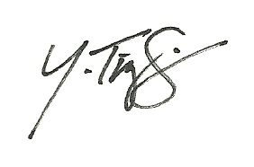

Yue-Ting Siu, TVI
UC Berkeley & San Francisco State University
ysiu@berkeley.edu

Appendix A. 3D Printing in Schools - Interim Report #2
Yue-Ting Siu, TVI
UC Berkeley & San Francisco State University

Date: January 21, 2014

Introduction

This report documents progress made on a one-year project, carried out by myself, Yue-Ting (Ting) Siu. The project carries out research in order to provide information regarding current practices using three-dimensional (3D) printing in schools, and the implications of these practices for students with visual impairments. The subcontract with Benetech for this project was approved in July 2013.

Executive Summary
An online survey provides general information regarding current uses of, and access to 3D printing by professionals who are responsible for providing tactile materials to students with visual impairments. Although the sample size of 163 respondents does not approach the true number of people working with this population of students, it encompasses people who are dedicated to providing accessible materials, particularly 90 TVIs whose primary responsibility is to ensure appropriate accommodations and education in the learning environment.
The preliminary research serves to provide a snapshot of this sample of respondents, all of who responded to an online survey that was disseminated over virtual networks. Despite these respondents demonstrating a higher level of technology use simply by accessing this survey, a very small number reported direct experience with 3D printing, and many were unfamiliar with using 3D printing to support students with visual impairments.
The greatest challenge to these respondents’ use of 3D printing for accessible materials was access to a 3D printer, and lack of resources and support in using this tool in the classroom. These barriers severely limit the abilities of professionals to explore the potential applications of this technology. Additional research regarding specific uses of 3D printing to support students with visual impairments will help to illustrate how this technology can be relevant and practical.

Activities completed this period

Application for approval from Instructional Review Board (IRB)
Upon further investigation into the need for IRB approval for this research, this project does not meet the definition of human subjects research, and therefore IRB approval was not necessary.

Conclusion of a survey titled “3D Printing for Accessible Materials in Schools”

Demographics

Respondents. The online survey was disseminated via social media (Twitter and Facebook), a variety of listservs dedicated to the education of students with visual impairments and personnel preparation, and newsletters and blogs including those sponsored by DIAGRAM and Benetech. Only those people creating tactile materials or currently working with students with visual impairments were invited to take the survey. Out of 163 respondents, A total of 126 (77%) worked in education as teachers, teaching assistants, learning specialists, college support staff, or parents. 90 respondents (55%) were teachers of students with visual impairments (TVIs). 74% of all respondents currently prepared tactile materials for students with visual impairments in the classroom.
Students served. 83% of the respondents served students from birth to transition ages/grades. 17% of the respondents served students in postsecondary education. 74% of the respondents currently prepared tactile materials for a student with a visual impairment in the classroom. Of the 90 TVIs, 77% served students as itinerant teachers (traveling between different school sites), 13% taught at a school for the blind, and others served students in a resource room or self-contained classroom.

Experiences with 3D Printing

Direct experience. Although most of the respondents (131 out of 163) had heard of 3D printing, only 13 people had direct experience either supervising or personally carrying out 3D printing activities, and 23 people currently used 3D printed materials in the classroom. Of these people with direct experience, 11 were TVIs, 1 was a researcher, and 1 was a blind student who oversaw her own 3D printed materials. Of the 23 people currently using 3D printed materials, these respondents were asked how they used the technology to provide accessibility in the classroom. Multiple answers were allowed to reflect the number of ways 3D printed materials were being used:

Anecdotal experience. 3D printing is a technology that has been developed for and applied in a number of different fields such as engineering, medical research, food science, art. One survey question affirmed the novelty of this technology in this demographic, and found that most of the respondents (87%) had only learned about 3D printing within the last three years. A survey question focused on respondents’ particular knowledge of 3D printing as applied to students with visual impairments found that although the largest majority of the respondents (131, or 80%) had heard of 3D printing, 54% of this group had never heard of 3D printing for students with visual impairments. The following graphs illustrate the respondents’ knowledge of the context for 3D printing activities, and the breakdown of what type of school environments they know of using 3D printed materials (based on 40 responses who identified with 3D printing in school). This information may be useful in understanding how these respondents are already familiar with 3D printing, and where people may seek access to a 3D printer. The “Other” category in question #12 includes hearing of 3D printing in general contexts via mainstream media such as the news, websites, television, and casual conversations.
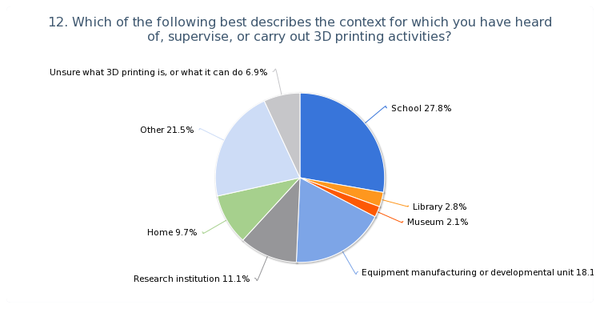
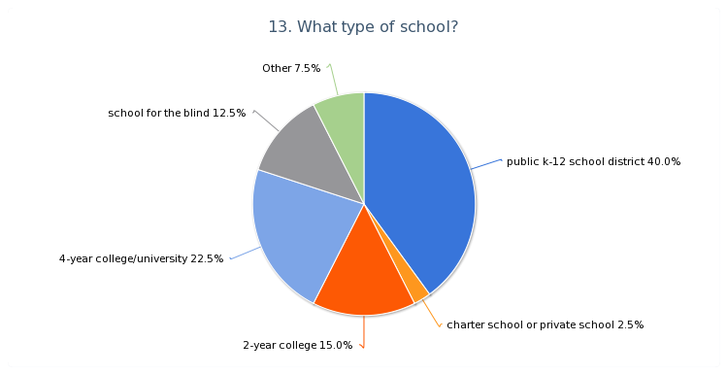

Access to 3D Printing

All 163 respondents were asked how easily they could access a 3D printer. 126 (77%) answered that it would be difficult, and require research and assistance to locate one to use. Of the remaining 36 respondents who knew of someone or somewhere with a 3D printer (1 respondent did not answer), the following locations were identified:
Location of 3D Printer | # of Respondents
School | 20
Library or Cooperative Center | 2
Research Lab | 9
Owned by Work or at Home | 5
These responses indicate that generally, 3D printers are not readily accessible to this sample of respondents who work with students with visual impairments.

Challenges in Using 3D Printing for Accessible Materials

The final question of the survey asked respondents to identify barriers in using 3D printing with students with visual impairments. Challenges must first be identified before recommendations can be made to overcome difficulties and find solutions. All of the respondents answered this question, and were allowed to select more than one challenge as well as offer their own. One the “Other” responses noted the inaccessibility of programs used to generate files needed to 3D print. Another respondent highlighted the capacity to use 3D printing to make multiple copies of a tactile graphic or object rather than a “one-off”. The respondents’ challenges are summarized in the following graph.

Overall, the greatest challenges were in all areas related to access; access to a 3D printer, access to materials needed to 3D print, and access to training and support in using a 3D printer. Other lesser yet shared challenges were related to not knowing how relevant this technology is for students who are visually impaired, and the familiar challenge of not having the time to take on this task.

Next steps
The survey concludes preliminary research on how and if 3D printing is currently used by professionals who provide tactile materials to students with visual impairments. At the close of the survey, 16 respondents provided an email for further contact and discussion of their experiences with and development of 3D printing initiatives. A follow up questionnaire will be sent to these respondents to gather more specific information about current uses of 3D printing.
Initial interviews with staff at various sites have commenced, and will continue with multiple staff at each site. The sites will be treated as case studies, and interviews and review of artifacts from each site will illustrate how 3D printing is currently implemented to benefit students with visual impairments. These sites include:

- Perkins School for the Blind
- Los Angles Unified School District
- NYC Department of Education (waiting for confirmation)
- Texas School for the Blind and Visually Impaired (waiting for confirmation)

Other stakeholders will be interviewed to report on other avenues of accessing 3D printing technology, challenges of its use, and examples of applications to provide accessible materials in schools. Stakeholders may include various organizations including advocacy groups, accessibility developers, educational researchers, libraries, assistive technology designers, and members from special interest groups related to the education of students with visual impairments.
Finally, a summary of market research data will provide a snapshot of 3D printing in general education for students without disabilities. This information will provide models of 3D printing use, and suggest how students with visual impairments and related professionals might also access this technology.
The research project is on track to conclude as expected by April 30, 2014.

This report is respectfully submitted by,

Yue-Ting Siu, TVI
UC Berkeley & San Francisco State University
ysiu@berkeley.edu

Appendix B. 3D Printing Research
Conducted between January-April 2014

3D Printers and their uses in schools, community

April 1, 2014: City X Project, curriculum for kids aged 8-12 downloaded from Internet. Used in Hungary, US, and now Singapore. http://www.cityxproject.com/toolkit/ Present a problem of humans landing on an alien planet and needing inventions to solve problems of transportation, communication, health, safety and more.

March 28, 2014: Sierra College Center for Applied Competitive Technology (CACT) loans 3D printer to high school for STEM education. One group of students invented a Fast Forward ski sensor, submitted to Quirky (online invention submission site, community decides what will make it to production) https://www.quirky.com/invent/945305/action/vote/query/sort=trending&categories=all

March 28, 2014: GE mobile lab called Fab Lab (http://www.gegarages.com/) traveled to Washingon, D.C. so public can access tools, such as 3D printers

March 25, 2014: http://www.tctshow.com/bright-minds-uk.html, where conference will set up glass-walled classroom in the middle of show floor for 500 attending secondary students to use 3D printers, 3D scanners, cube technology

March 25, 2014: Family-friendly maker space in The Exploratory in Culver City offers 3D printing class for kids

March, 2014: Golden State Warriors, America Makes, MakerBot collaborating to get 3D printer package for Oakland HS. Already more than 1,000 schools have gotten 3D printers through America Makes program.

March 18, 2014: 3 high school students in Loveland, OH created a 3D bioprinter and can print bacteria (http://3dprintingindustry.com/2014/03/18/3d-bioprinter-loveland-school/)

March 4, 2014: Maker Bot classes in CT will be broadcast to Uganda and other places. Teach STEM classes in US about 3D printing to groups of five local 4th and 5th graders and students at Gayaza High School in Uganda about 3D printing and will construct battery-powered reading light cases to address power problems in Uganda.

Feb 24, 2014: Van Meter Library in Van Meter, Iowa got a MakerBot Replicator 2 (3D printer), so she is starting a social media website for kids to learn about 3D printing: http://www.symbaloo.com/mix/3dprintingfun

Feb 21, 2014: http://3dprintingindustry.com/2014/02/21/chicago-magnet-school-launch-40000-3d-printing-lab/
Walt Disney Magnet elementary school will have a 3D printing lab to build materials for local school for the blind. They are making braille labels to help students learn to read braille.

Feb 4, 2014: http://www.govtech.com/products/Does-3-D-Printing-Change-Everything.html
Professor Christopher Williams, who heads up Virginia Tech's Design, Research, and Education for Additive Manufacturing Systems (DREAMS) Laboratory, said the technology will lead to more entrepreneurial opportunities for young people. "Here at Virginia Tech we have a lot of smart students with neat ideas they sketch out on napkins, and they can do CAD drawings of them. But they need to make a mockup of ideas, and that has always been an expensive hurdle," he added. "But the ability to make a model is now much more accessible. One of the most powerful examples of the impact Williams could think of was a blind physics student who was studying 3-D calculus. "Her professor could print out spatial visualizations to make the concepts clear," he said.
January 27, 2014: Indian 3D Printing Project Is Helping the Visually Impaired to “Fittle” Right In http://3dprintingindustry.com/2014/01/27/indian-3d-printing-project-helping-visually-impaired-fittle-right/ Fittle project: 3D printed puzzles that combine shapes, words, and textures to allow visually impaired children to better visualize the world around them.These puzzles are designed in the shapes of various objects, with the name of the object printed onto the puzzle in Braille. This concept allows kids to not only learn the word, but the shape of it as well –allowing them to visualize the object. Fittle + Yahoo Japan = “Hands On Search” project (http://www.fittle.in/yahoo-japan.html). Look for a printer near you: http://www.3dhubs.com/

November 15, 2013: MakerBot with DonorsChoose.com, AutoDesk, and America Makes to provide 3D printer bundles to every school in America. 82 requests already funded only 48 hours into the program.

November 12, 2013: MakerBot joins with DonorsChoose.com in a goal to have a 3D printer at every school in the US. The CEO, Bre Pettis pledged to put 3D printers in public high schools in Brooklyn. “Each MakerBot Academy bundle contains a MakerBot Replicator 2 Desktop 3D Printer, three spools of MakerBot® PLA Filament, and a full year of the MakerBot MakerCare™ Service and Protection Plan.” Kicked off by quote from President Obama: “3D printing has the potential to revolutionize the way we make almost everything. The next industrial revolution in manufacturing will happen in America. We can get that done.”

November 11, 2013: MakerBot is donating several of its popular 3D printers, the
MakerBot® Replicator® 2 Desktop 3D Printer, to seven schools for the blind in Japan in conjunction with Yahoo Japan.” Print models of objects so students can experience them, such as scorpions, Statue of Liberty, other things that wouldn’t be safe or feasible to touch. Use designs from the “MakerBot® Thingiverse® website, the world’s largest 3D Design Community with more than 100,000 downloadable digital designs for discovering, printing and sharing 3D models.”

April 22, 2013: 3D Printing in Libraries Around the World
http://www.3ders.org/articles/20130422-3d-printing-in-libraries-around-the-world.html
Shows where 3D printers are being adopted by libraries around the world (concentration in US), what types of libraries are using them, how they are using them, and what kinds of 3D printers they own. Among 51 libraries, there are varying usages: 23 libraries identified with having a function for their 3D printers, 6 offer a 3D printing service, meaning they will take in patron STL files (3D model files) and print the object, at least 11 of them offer a patron work environment, calling them either makerspaces, hackerspaces, fab labs, studios, or innovation labs, 4 libraries have listed PLA plastic filament their base printing material. Reasons for underuse include: technological unpreparedness, budgetary, staffing and spacing constraints, being of the opinion that 3D printing has no place in a library mission, and lack of knowledge. For libraries with 3D printers, policy development should be a top priority.
Mar 26, 2013: UC Berkeley Students Build 3D Printing Vending Machine
http://science.kqed.org/quest/2013/03/26/uc-berkeley-students-build-3d-printing-vending-machine/
The Dreambox: first fully automated 3D-printing vending machine. You can print almost any object using its touchscreen and watch said object materialize before your eyes.

March, 2013: Importance of 3D Printing in Education
http://www.educatorstechnology.com/2013/03/importance-of-3d-printing-in-education.html
7 minute video highlights on “Will 3D Printing Change the World?” (by PBS OffBooks). Much of what’s printed in education is not protected by copyright (different from books and images). Steps for printing.
Feb. 19, 2013: 10 Ways 3D Printing Can Be Used In Education
http://www.teachthought.com/technology/10-ways-3d-printing-can-be-used-in-education/
What it is you’re actually producing depends on what is being printed: if it’s toy jewelry, rubber balls, and plastic chess pieces your after, you’re printing not an analogue of the real thing, but the real thing itself. Great examples of application in education across various subject. Summarizes benefits of 3D prints: Multi-modal – good for tactile learners, Bringing subject to life; more powerful learning experience, Prototyping for exploration & creation.
October 19th, 2012: The future of higher education: reshaping universities through 3D printing
http://www.engadget.com/2012/10/19/reshaping-universities-through-3d-printing/
Earlier this year, the building's DeLaMare Science and Engineering Library became one of the first academic libraries in the United States to provide 3D scanning and printing to all students and faculty, as well as the public. The move is part of a plan by director Tod Colegrove to transform the facility from a typical library that promotes knowledge through books to one that also encourages creative thought and discussion via hands-on technology. "If you look back at libraries over 2,000 years -- including the Library of Alexandria -- you'll see that they were involved in buying technology that many people cannot afford and making them more accessible,"Colegrove said. "Along the way, it became all about having the biggest and best book collection so you ended up having identical libraries. We lost our way." Huge adoption at University of Nevada, Reno, as well as Columbia – Architecture, Planning and Preservation, MIT – mechanical engineering, Harvard – medical school

3D Printing in libraries, museums, other community organizations

- Lovejoy Library, Southern Illinois University Edwardsville
http://siue.libguides.com/content.php?pid=348515&sid=2851133
Established printing guidelines/process, Helpful links to major 3D file repositories
- 3D Printing at UW
http://video.seattletimes.com/1279920256001/3d-printing-at-uw/ 3 min video demoing how 3D printing happens and also few anecdotes about creative application at school (encouraging realization of design)
- October 10, 2013: 3D Printing to Help Visually-Impaired Experience Visual Art in Texas
http://3dprintingindustry.com/2013/10/10/3d-printing-help-visually-impaired-experience-visual-art/
The Ellen Noel Art Museum is using these machines to aid in the experience of art for the visually-impaired. George Jacob the director of the museum hopes to create a series of kits with Braille instructions to allow the visually-impaired to learn about art through touch. Then, the plan is to lend these kits to other institutions and museums so that they, too, can provide this experience to their non-seeing patrons.
- Children’s Museum of Pittsburg: https://pittsburghkids.org/
- Chicago Public Library: http://www.chipublib.org/tag/3d-printing/

Other

- In chatting with someone from MakerBot, they are saying "over 200 schools" got printers through the MakerBot Academy program through DonorsChoose.org. They said 6-7 schools in Brooklyn got the printers through DonorsChoose. The CEO put his money into DonorsChoose for those schools, but they seem to always filter through that website. The guy I chatted with said that he filed the paperwork for the first 220 schools. That seems to be all they know. If you go to the website MakerBot.com/academy, there is the option to chat on the side.
- http://3dprintingindustry.com/education/ (many more articles)

Peer-reviewed article search

DeNisco, Alison. (2012). Fab Labs: Using technology to make (almost) anything! District Administration, 48(11), 34-37. Mahtomedi, MN district the first public school district with a fabrication lab, where students can design any object electronically and then a 3D printer uses materials to create the object by laying down layers of material based on the virtual design. https://www.fablabs.io/mahtomedihighschool
Greenberg, A. (2009). Integrating nanoscience into the classroom: Perspectives on nanoscience education projects. ACS nano, 3(4), 762-769.
Lacey, Gary. (2010). Get students excited--3D printing brings designs to life.
Tech Directions, 70(2), 17-19.
Students in technology education programs in middle and high school using inexpensive 3D printers, such as RapManUSA, to learn aspects of design and manufacturing by doing rapid-prototyping. Rapid-prototyping turns computer-designed models into a 3D physical model.
Mertz, L. (2013). Dream it, design it, print it in 3-D: What can 3-D printing
do for you? Pulse, IEEE, 4(6), 15-21. doi: 10.1109/MPUL.2013.2279616
Suescun-Florez, E., Iskander, M., Kapila, V., Cain, R. (2013). Geotechnical engineering in US elementary schools. European Journal of Engineering Education, 38, 300-315.
Used a 3D printer during an erosion activity to construct models. Results show that students increase understanding of engineering principals (in combination with other modeling of soil permeability, contact stress, soil stratigraphy, shallow and deep foundations not using 3D printer).
Teshima, Y., Matsuoka, A., Fujiyoshi, M., Ikegami, Y., Kaneko, T., Oouchi, S., ... & Yamazawa, K. (2010). Enlarged skeleton models of plankton for tactile teaching. In Computers Helping People with Special Needs (pp. 523-526). Springer Berlin Heidelberg.
Wedler, H. B., Cohen, S. R., Davis, R. L., Harrison, J. G., Siebert, M. R., Willenbring, D., Hamann, C. S., Shaw, J. T., Tantillo, D. J. (2012). Computational chemistry for the blind and visually impaired. Journal of Chemistry Education, 89, 1400-1404:
Wedler, H. B., Boyes, L., Davis, R. L., Flynn, D., Franz, A. K., Hamann, C. S., Harrison, J. G., Lodewyk, M. W., Milinkevich, K. A., Shaw, J. T., Tantillo, D. J., Wang, S. C. (2014). Nobody can see atoms: Science camps highlighting approaches for making chemistry accessible to blind and visually-impaired students. Journal of Chemistry Education, 91, 188-194.

Appendix C. 3D Printing in a High School Biology Class

Provided by Mike Cheverie, TVI
Los Angeles Unified School District
3D Printing for Accessible Materials in Schools – DIAGRAM Center webinar 4/30/14

CA State Standards:
Cell Biology
The fundamental life processes of plants and animals depend on a variety of chemical reactions that occur in specialized areas of the organism’s cells. As a basis for understanding this concept:
Students know cells are enclosed within semipermeable membranes that regulate their interaction with their surroundings.
h. Students know most macromolecules (polysaccharides, nucleic acids, proteins, lipids) in cells and organisms are synthesized from a small collection of simple precursors.

Common Core Standards:
HS-LS1-6. Construct and revise an explanation based on evidence for how carbon, hydrogen, and oxygen from sugar molecules may combine with other elements to form amino acids and/or other large carbon-based molecules.

Phospholipid Model

Hydrophilic Phosphate Head:

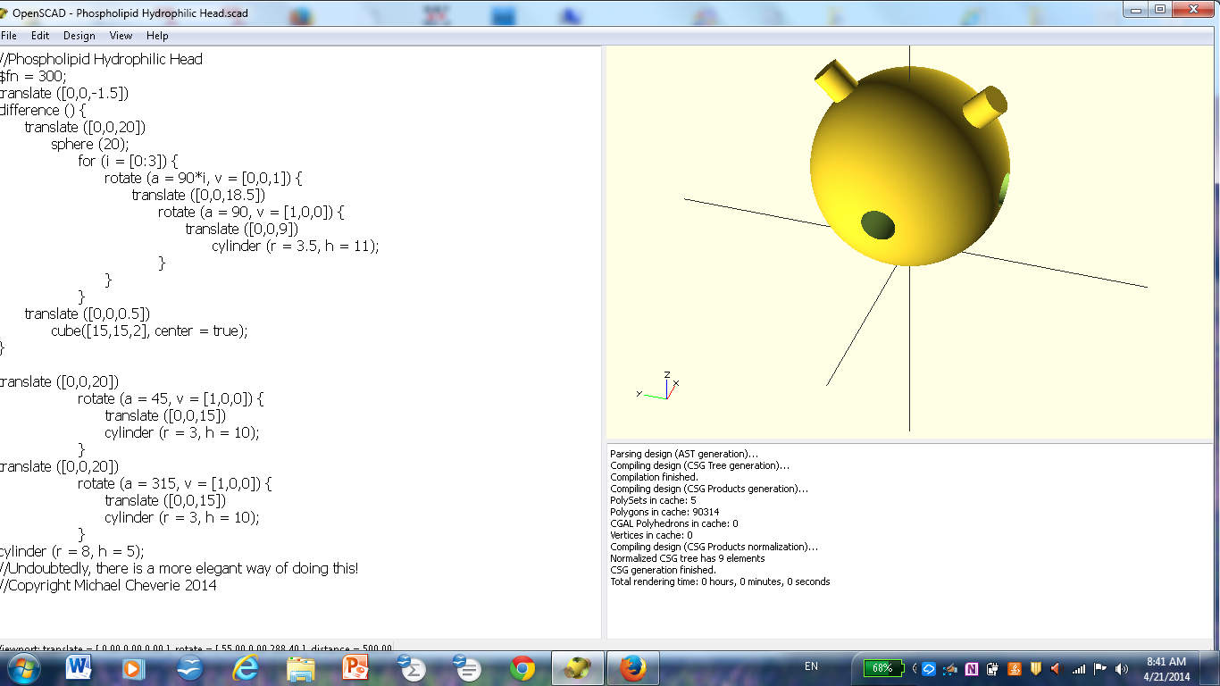

Hydrophobic Lipid Tail Piece:

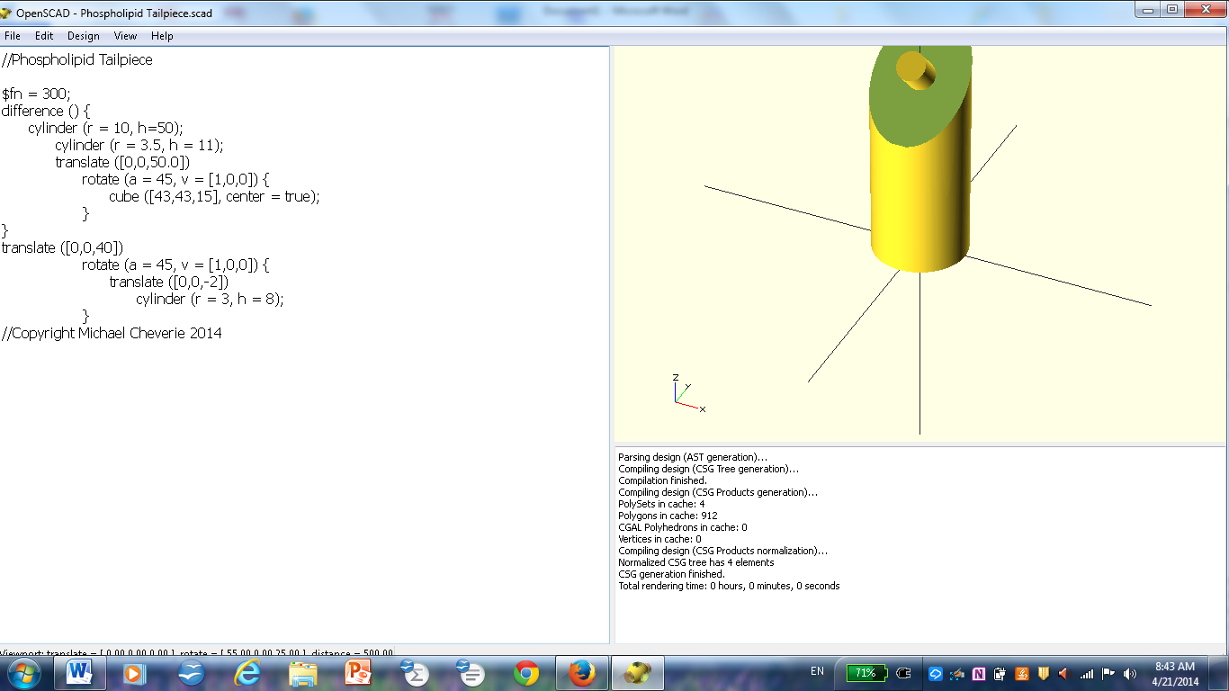

Hydrophobic Lipid Tail Piece (Alternate View):

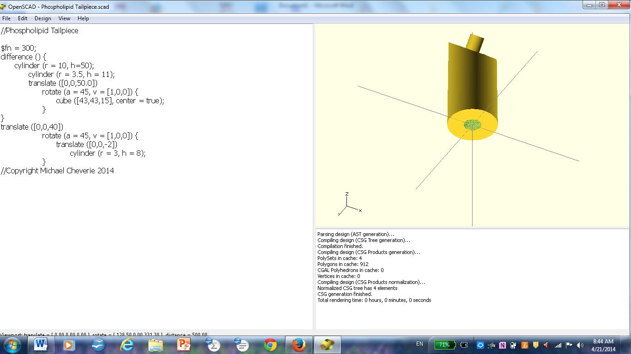

Connector Piece (for Phosphate Heads):

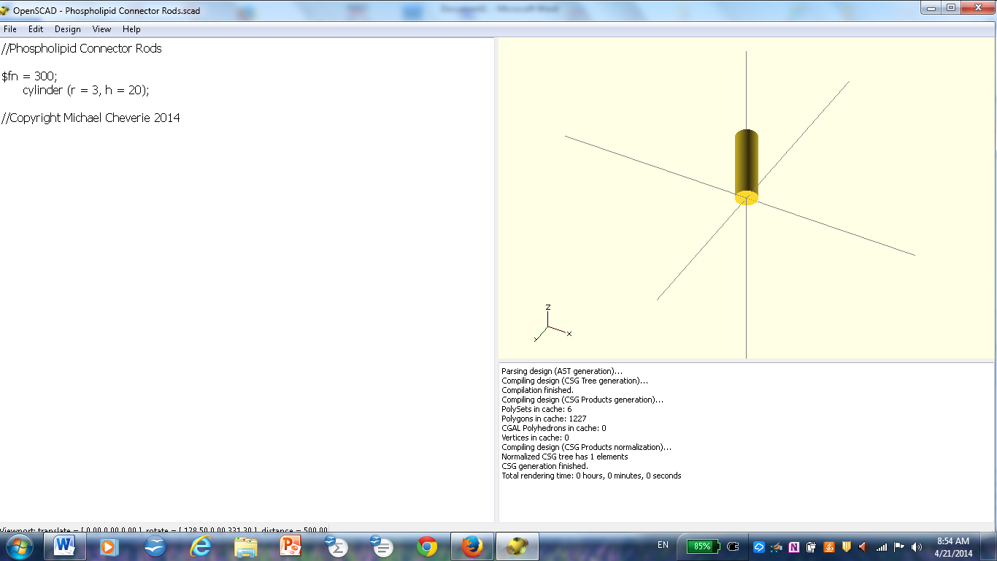

Phospholipid Tailpiece Connectors:

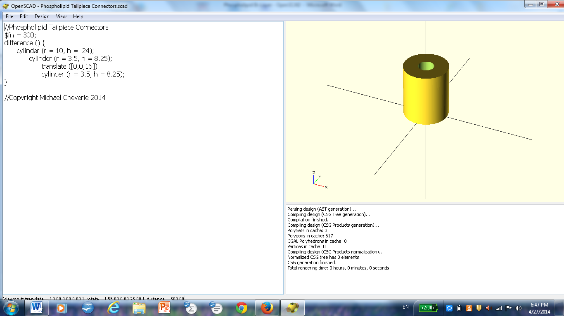

To make a phospholipid:
1. Connect one tail piece to each of the posts of the phosphate head.
2. Connect another tail piece to each of the tail pieces connected; repeat two more times, for a total of four tail pieces for each of the posts on the phosphate head.

To make a phospholipid sheet:
1. Use the connector piece for the phosphate heads to connect four phospholipids to a central phospholipid. (Note that each phospholipid has four lateral holes that will accommodate a connector piece for attachment to other phospholipids.)
2. Repeat this pattern to produce one sheet of phospholipids.

To make a phospholipid bi-layer:
Use the phospholipid tailpiece connectors to attach one sheet of phospholipids to an inverted sheet of phospholipids.

