Provided by Mike Cheverie, TVI
Los Angeles Unified School District
3D Printing for Accessible Materials in Schools – DIAGRAM Center webinar 4/30/14

Phospholipid Model

Hydrophilic Phosphate Head:
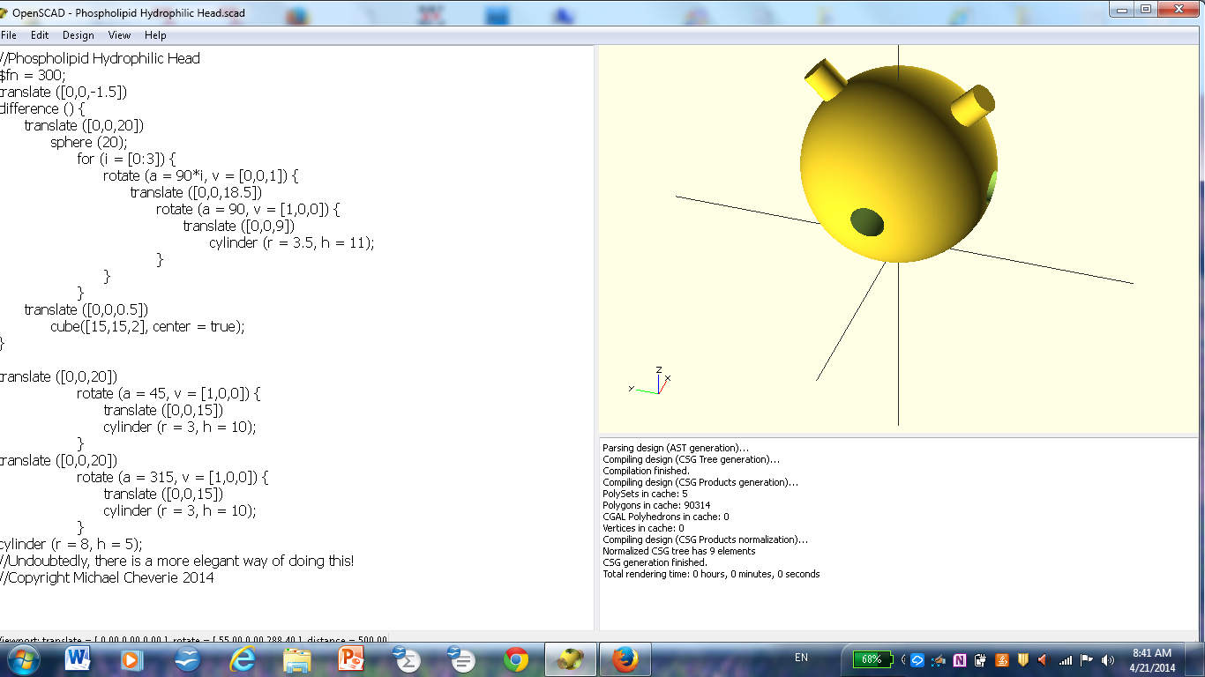

Hydrophobic Lipid Tail Piece:
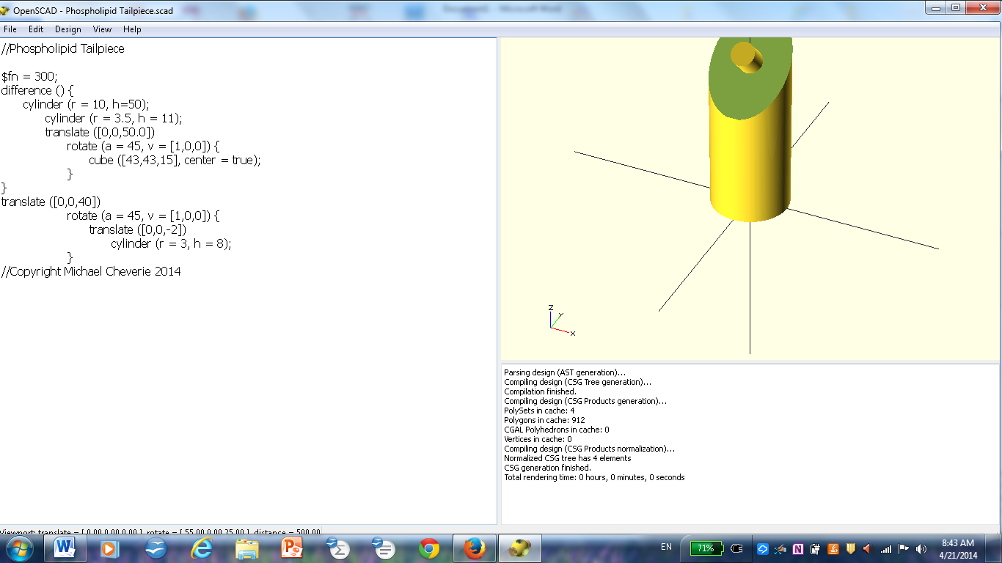

Hydrophobic Lipid Tail Piece (Alternate View):
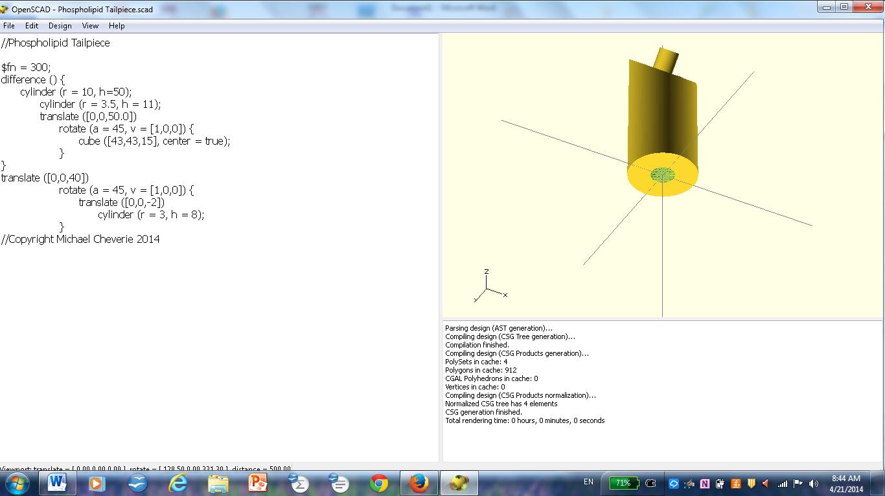

Connector Piece (for Phosphate Heads):
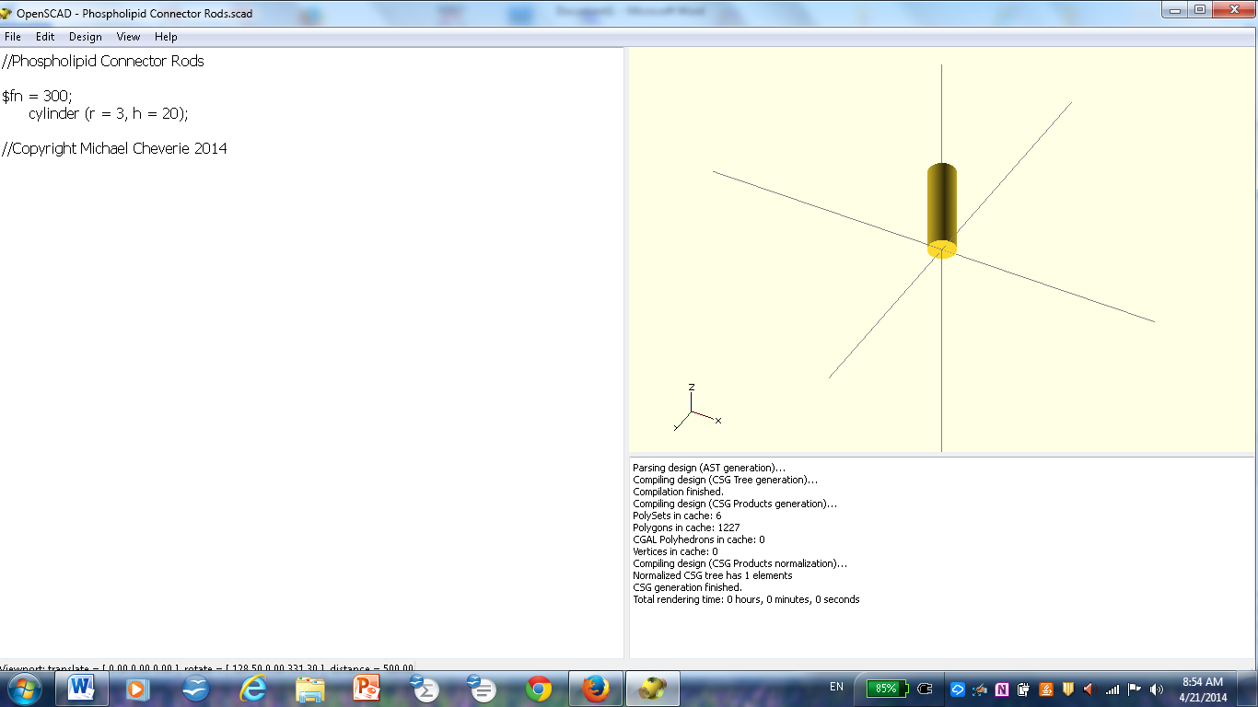

Phospholipid Tailpiece Connectors:
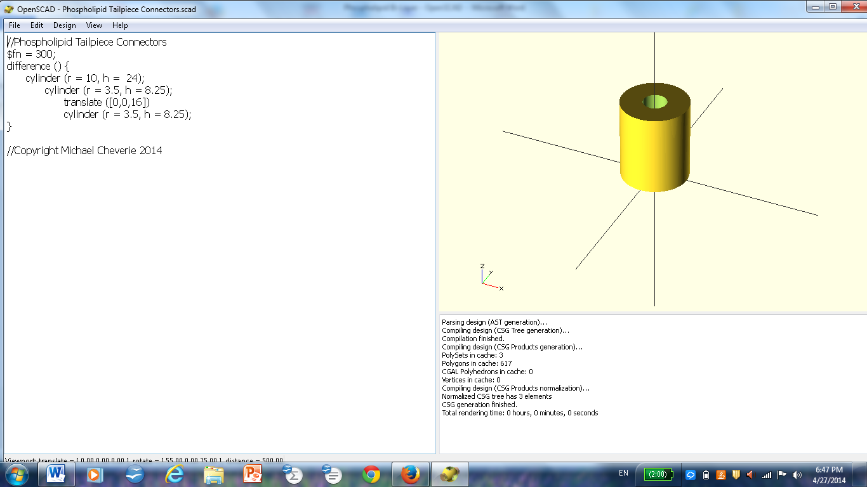

To make a phospholipid:
1. Connect one tail piece to each of the posts of the phosphate head.
2. Connect another tail piece to each of the tail pieces connected; repeat two more times, for a total of four tail pieces for each of the posts on the phosphate head.

To make a phospholipid sheet:
1. Use the connector piece for the phosphate heads to connect four phospholipids to a central phospholipid. (Note that each phospholipid has four lateral holes that will accommodate a connector piece for attachment to other phospholipids.)
2. Repeat this pattern to produce one sheet of phospholipids.

To make a phospholipid bi-layer:
Use the phospholipid tailpiece connectors to attach one sheet of phospholipids to an inverted sheet of phospholipids.

